Genesis: A Computational Architecture for Execution, Inference, and Recoverable State
EM Foundation for AI Research · Research Publication 13 · Working Paper
Publisher: EM Foundation for AI Research, Inc. Author: Desmond Iwuagwu E. with EM Foundation for AI Research Status: Working Paper Date: October 2026
This is the Word version of the full Working Paper. The web versions are at emfoundation.net/paper-genesis-foundations.html (short) and emfoundation.net/paper-genesis-foundations-full.html (full).
What this paper does and does not claim. This paper introduces Genesis, an experimental research program asking whether execution, authority, verification, state and recovery can share one explicit semantics, and reports what that program has and has not established. It reports finite, checkable results: observation-relative quotient sizes (§5), an authority algebra of seven transformation maps, none of which can restore spent authority (§6), a restricted single-host preview that an independent reviewer rated conditionally ready for private use (§11), and a work-elimination result in which a 272-case equivalence check needs 32 interpreter calls instead of 546 (§7). It does not claim that Genesis is faster than conventional software: a conventional implementation using the same idea ran within about 7 percent of it (§9). It does not claim that the work-elimination result holds for arbitrary programs, that any capability extends to concurrent or multi-host systems, guarantees exactly-once effects at outside services, or survives hardware power loss (§14), or that any energy saving has been measured. It does not claim that one unified representation can carry every guarantee; the research itself found no evidence for that (§3). It does not claim that RC8's recover command proves a task was recovered: the independent evaluation found that it can report success for a recovery that failed, and a recovered RecoverableUnknown state means the outcome is still explicitly unresolved, not that the work was completed (§11.5). Several numbers in the original research records contradicted each other; this paper recomputed them and lists every correction in Appendix D. The developer's experiments have not yet been independently replicated.

Abstract
Genesis is an experimental programming language and computational architecture in which execution, authority, verification, state and recovery are given one explicit and mutually consistent semantics, so that some computational work can be inferred rather than repeated. It was originated by Desmond Iwuagwu E. and has been developed at EM Foundation since October 2026. Its motivating case is ordinary. A program that sends a payment and crashes before the reply arrives cannot tell, when it restarts, whether the payment went through. What it should do next depends on questions conventional systems answer in separate subsystems that rarely share a definition of state: what is known, what may safely be retried, what the program is still permitted to do, and what an auditor can later prove.
This paper reports the program's results in full, including its failures. It defines an observation frame in which an unconfirmed external effect is recorded as a set of possible outcomes rather than as done or not done. It shows, with finite models checked by two independent algorithms, that the size of an exact summary of state depends on who is observing: one 128-state model compresses to 16 classes for one question, 64 for another, and not at all for a third. It establishes that the four-state authority model (Live, Delegated, Consumed, Abandoned) generates seven distinct transformation maps, every one of which can only lower authority, so that no sequence of operations can restore spent authority; the natural "invertible" alternative is shown to mint authority. It describes a restricted, single-host toolchain that an independent reviewer rated conditionally ready for private preview (six gates passed, six conditional, none failed), and presents a six-module program that the reviewer ran. Given correct inputs, the interpreter and verifier accepted a recovery of that program; the toolchain's recovery command, however, has a defect: it reported success for a recovery that had failed. As a case study, it reports that an equivalence check over 272 branch-and-interruption cases can be performed with 32 interpreter calls instead of 546 by projecting every interruption from one complete run per branch, matching brute force exactly on both tested programs. A conventional implementation using the same projection performs almost identically, which locates the saving in the idea rather than in the language. Three tempting mathematical shortcuts (a polarity flip, symmetry-based sampling and a helical law for interruptions) are shown to fail on explicit counterexamples.
The result is a narrow but durable foundation: a vocabulary for what interrupted computation must remember, conditions under which repeated execution can be replaced by exact inference, and a preserved record of where that replacement fails.
Keywords: interruptible computation · crash recovery · uncertain external effects · observational equivalence · quotient state · partition refinement · capability and authority models · state-transition algebra · authenticated history · computational work elimination · negative results · AI-assisted research
Reading the evidence labels
Every substantive claim in this paper carries one of six evidence classes, and, where relevant, a tag saying who checked it. The classes are the controlled vocabulary of the claims ledger in Appendix A.
[Established mathematics] a result that follows from stated definitions by a short argument; not machine-checked.
[Verified implementation] behavior reproduced by tests against an identified implementation and environment.
[Experimental observation] a result measured or recorded within a bounded workload.
[Supported inference] a conclusion justified by the evidence but not established in general.
[Research hypothesis] a claim that is plausible, proposed or specified, but untested.
[Refuted or unsupported] a claim contradicted by a counterexample or lacking support.
Verification tags: [Developer] tested by the system's builder; [Independent] tested against a frozen artifact by a separate AI agent that did not build it (see the note below); [Editorial re-check] recomputed for this paper from the original code and data. An editorial re-check is not an independent replication.
What "independent" means here. The independent reviewer, recorded as Kimi K, is an AI agent separate from the agent that built Genesis. It worked from a clean install of the frozen distribution and wrote its own tests and programs. That is a meaningful check, but it is not independent replication in the usual scientific sense: the reviewer operated in the same owner's environment, under direction from the same research program, and no human team or separate institution has repeated the work. The reviewer's own scripts, including the recovery reference procedure, have not been reviewed by a third party. Results tagged [Independent] should be read with that in mind.

1. Why Genesis Exists
Genesis is an experimental programming language and computational architecture. Its working toolchain reads programs written in a small, restricted package format, derives the checks it will later apply from the program source itself, runs the program while keeping an explicit ledger of what the program is permitted to do, records durable evidence of what happened, and uses that evidence to verify a run and audit its history. It is also designed to recover an interrupted run; in the current preview the recovery command has a reported defect (§11.5). Around that toolchain sits a research program that asks how much of this work must actually be performed and how much can be inferred. Figure 2 shows the parts and which of them exist today.
Much of the cost of modern computation is not new work. It is the same work done again: a program re-run to learn what state it would have reached had it been interrupted somewhere else, a recovery routine replaying steps already taken, a verifier re-deriving what the runtime already knew. Faster hardware makes each repetition cheaper, but it leaves open whether the repetition was necessary, and whether the system even has a precise enough description of its own state to answer that question.
Genesis began as an attempt to ask it. The research record opens on 10 October 2026 with an empty project directory: no runtime, no semantics, no benchmark, and an explicit statement that every model and predicted result at that point was a hypothesis. The program's founding charter asked whether execution, memory, verification, causal explanation and failure recovery could be given compatible semantics; it treated conventional programming paradigms as points of comparison rather than axioms; and it required every model to state what it could not guarantee.
Genesis was originated by Desmond Iwuagwu E., who directs the research program for EM Foundation. He set its foundational question, its research direction and its standard of evidence, and directed the AI research agents that carried out much of the work: they formalized models, wrote and ran code, attacked their own results, and in one case reviewed another agent's work independently (§16 records the roles). The program is therefore human-directed and AI-assisted, and the interest of this arrangement is methodological rather than promotional. It produced a traceable path along which a conceptual question became a mathematical model, the model became falsifiable claims, most of those claims were falsified, and the survivors became running software with a stated and tested scope. The roles described in this paper are scientific attributions. They are distinct from legal inventorship, which this paper does not address.
The central question the paper addresses is:
Can computation be organized around mathematically explicit relationships between execution, authority, verification, state and recovery, such that some computational work can be inferred rather than repeatedly executed, and can the conditions under which that inference is valid be stated exactly?
The answer reported here is a qualified yes on a small domain, a clear no for several attractive generalizations, and an open question everywhere else.

2. The Computational Problem

2.1 The lost acknowledgment
The problem that anchors the program is old and simple. A long-running workflow sends a request to an outside system (a payment processor, a carrier, another service) and is interrupted before the reply arrives. After restart, its local record is consistent with two different worlds: the action never happened, or it happened and only the acknowledgment was lost. Retrying in the second world duplicates the effect. Declining to retry in the first loses the work. No amount of local logging distinguishes them.^{14,15}
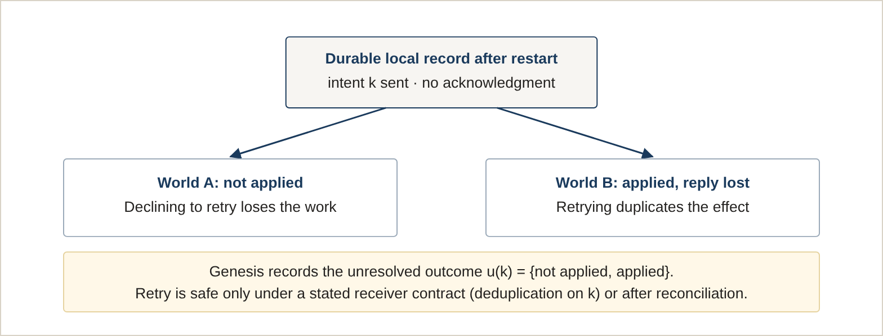
Figure 1. The lost-acknowledgment case (counterexample CE-3 in the research record). A durable intent record cannot distinguish the two worlds, so the uncertainty must be represented rather than resolved by assumption. [Established mathematics]

2.2 The separation problem
Conventional stacks divide the surrounding questions among separate subsystems. A compiler or interpreter reads the program; a runtime executes it; an authorization layer decides what it may touch; a storage engine persists its state; a recovery mechanism restores it; an audit trail records what happened. Each part is usually correct on its own terms. The difficulty is at the seams. Whether a recovered program may still exercise a permission it held before the crash, whether two checkpoints are interchangeable for resuming but not for auditing, whether a cached result was computed under the authority of the call now reusing it: each of these spans at least two subsystems, and in most stacks no single component owns the answer.
The separation has three costs that motivated Genesis. Work is duplicated because each subsystem reconstructs facts the others already hold. State is represented inconsistently because each subsystem keeps its own notion of "the same state". And recovery is ambiguous because the conditions under which it is correct (what the receiver guarantees, what an acknowledgment means, how long deduplication keys are retained) are usually assumed rather than written down.^{3,16}
None of these observations is new, and Genesis does not claim to have discovered them. Its contribution, if it has one, is to treat them as a single design problem and to test which parts of a joint treatment survive contact with counterexamples.

3. How the Question Narrowed
The early phases of the program were adversarial by design, and most of the attractive ideas did not survive them. Seven hand-worked counterexamples removed claims that had seemed natural, among them that provenance edges explain results, that local contracts compose, that a durable intent settles an external effect, that compensation inverts an effect, and that recursive or "fractal" interfaces confer an advantage of their own. Section 10 lists them with what each changed.
An architecture tournament then compared five candidate calculi for a unified semantics: an evidence-preserving transformation calculus, a causal-continuity calculus, a composable kernel, a multiscale calculus, and invariant-guided recovery. It declared no empirical winner. It ranked the evidence-preserving calculus as the strongest single-calculus hypothesis and the composable kernel as the strongest multi-calculus one, and labeled both as hypotheses.
A negative result that shaped the program
A later review (the "H6 reset") concluded that the work to that point had established conditional claims but had not shown that one internal representation must carry every guarantee, and that a unified wrapper had not outperformed conventional typed services. From that point the program stopped pursuing a universal calculus and concentrated on a narrow, testable surface. This paper accordingly presents Genesis as a research architecture with a shared vocabulary, not as a demonstrated unified mathematics of computation. [Refuted or unsupported] (the unification claim)
Two further lines were bounded rather than abandoned. A portable artifact format was found to presuppose an unavoidable shared bootstrap kernel, and bounded component synthesis was found to be exact only within a stated catalog and depth. What remained after these reductions is what the rest of this paper describes: an observation frame (§4), observation-relative summaries (§5), an authority algebra (§6), a work-elimination technique (§7 to §9), and a restricted toolchain that implements part of this (§11).
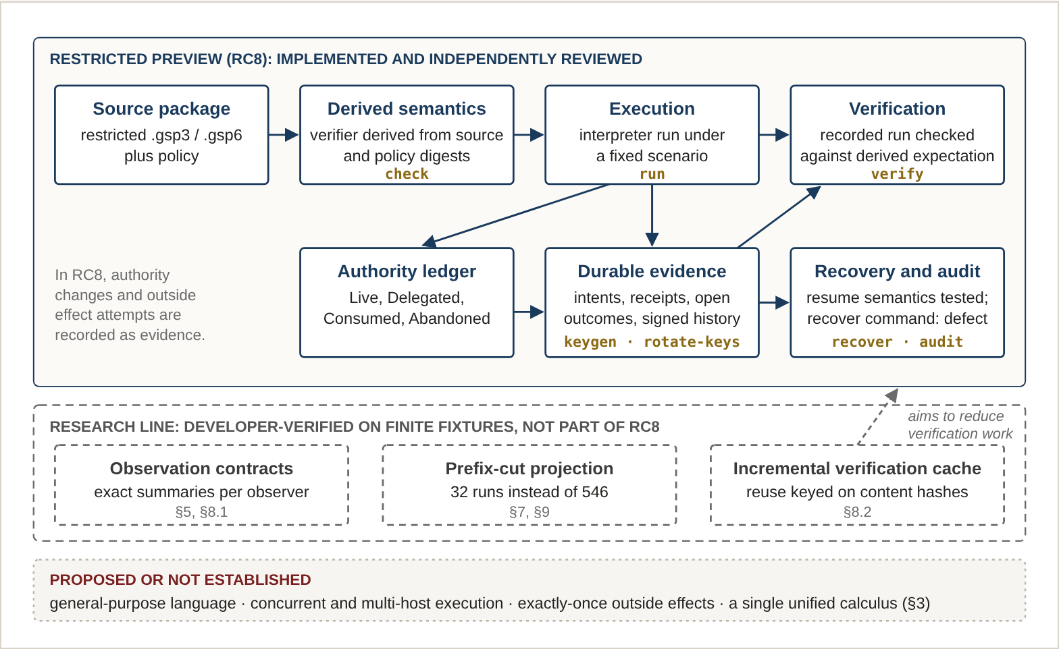
Figure 2. The Genesis architecture. Solid boxes are implemented in the restricted RC8 toolchain and were exercised by the independent review (§11); gold labels are its commands. Dashed boxes are research mechanisms tested by the developer on finite fixtures and not part of RC8. The bottom band lists directions that are proposed or that the research found no support for. The language-level recovery semantics were tested independently with correct inputs, but RC8’s recover command has a reported status defect (§11.5). Arrows show data flow, not proof obligations. [Verified implementation] (top band)

4. The Observation Frame
The observation frame is the research program's basic definition. It fixes a program P, an environment contract A, and a set of actors. A configuration is a six-part state
C = (q, M, D, X, O, K)(1)
consisting of actor control q, volatile memory M, durable internal memory D, external-system state X (possibly unobservable), a durable outbox O of intents and receipts, and the set K of obligations and assumptions currently relied upon. A crash erases volatile state and keeps only what A declares durable. That is an assumption about the environment, not a property of disks, and the frame says so. [Research hypothesis] (as an architecture)
An observation of a run r is a six-tuple
Obs_{A}(r) = (v, d, t, f, u, z)(2)
of returned values, durable state, externally confirmed effects, failure and recovery status, unresolved effect intents, and observable happens-before constraints.¹⁷ The component u is the point of the frame. It records an effect not as done or not done but as a set of possible external outcomes, for example {not applied, applied}. The observer's knowledge set K_{A}(r) is the set of observations consistent with the durable evidence, and a statement that an effect did not occur is valid only if every member of that set excludes it. This is epistemic uncertainty, not probability.
Central construct
Unresolved outcomes are first-class. A local send record is not confirmation. Compensation (a refund, a cancellation) is a new effect with its own uncertainty, not the inverse of the original, and the history keeps both. Every recovery guarantee is conditional on named environment assumptions: receiver atomicity, the meaning of an acknowledgment, retention of idempotency keys, query consistency and the fault model.
The frame also separates modes of explanation, because they can disagree. In y := x OR w with x = w = 1, a dependency path runs from x to y, yet intervening on x does not change y, while x = 1 is still sufficient for y = 1. Structural reachability, counterfactual dependence and sufficiency are different questions, and an explanation must say which it answers.¹⁸ [Established mathematics]

5. Exact Summaries Depend on the Observer

5.1 When a state can be summarized exactly
Every optimization that skips work replaces a full state with a summary. The question is when the summary loses nothing that matters. Two short results, both standard and neither presented as new, give the discipline Genesis uses.
Theorem 1 (exact abstract transformer). [Established mathematics]
For a summary α : S → A and a transformation T : S → S, there exists a function T̄ with T̄(α(s)) = α(T(s)) for all s if and only if α(s) = α(t) implies α(T(s)) = α(T(t)) for all s, t.
Theorem 2 (query-relative sufficiency). [Established mathematics]
For a family Q of queries, a summary answers every query in Q exactly if and only if α(s) = α(t) implies q(s) = q(t) for every q ∈ Q. The coarsest exact summary is the partition induced by Q. If Q includes questions about the future, that partition may be much finer than a summary of current output.
These are facts about quotients of transition systems, closely related to completeness in abstract interpretation and to bisimulation minimization.^{1,2,5} Their role in Genesis is a discipline rather than a discovery: a summary is never "the" compression of a state, only the compression for a declared observer and a declared set of actions. The instructive case is a summary that keeps only an account balance. It merges a state with a pending, uncertain charge and a state without one, and a retry then tells them apart.
Central construct
Observation contract: an explicit statement of which present and future questions a reduced state must still answer. Two histories can be equivalent for resuming execution and distinguishable for audit. Genesis therefore never asks whether two states are "the same", only whether they are the same with respect to a named contract.
Figure 3 shows the idea with two short histories. They end in the same recoverable state, so a summary made for recovery may merge them. They are not the same record of what happened, so a summary made for audit must keep them apart.
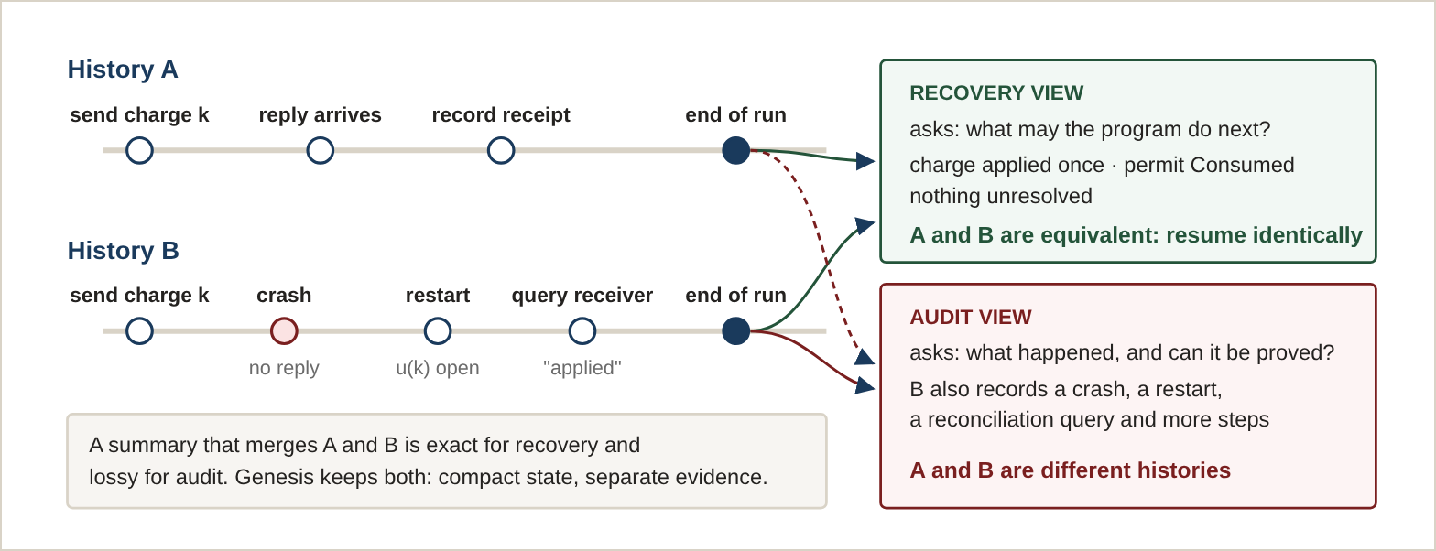
Figure 3. The same pair of histories is one class or two depending on the observation contract. History B recovers from a lost reply by querying the receiver; afterwards both histories permit exactly the same future behavior, so a recovery summary may merge them, while an audit must keep them apart. Illustrative example, not drawn from the test fixtures. [Established mathematics] (Theorem 2 applied to two observers)

5.2 Finite checks
The research tested this on three finite automata, using two independently coded algorithms (forward partition refinement and backward pair-distinguishability) that agree on every class, not only on class counts, plus a direct pairwise check of each proposed class. [Experimental observation] [Developer]
Model and observation | States | Exact classes | Why
Durable-parity model; parity of current and durable values, effect, alias | 128 | 16 | Noise and upper bits are unused by every admitted action: four meaningful bits instead of seven.
Same model; exact current value, effect, alias | 128 | 64 | A crash reveals the exact durable value, so the stable partition is finer than the current-value question suggests.
Same model; all five fields | 128 | 128 | No compression.
Sliding-window model; current sum and effect | 8 | 8 | Histories 01 and 10 have the same sum, but appending 0 gives sums 1 and 0. Stable refinement separates all eight.
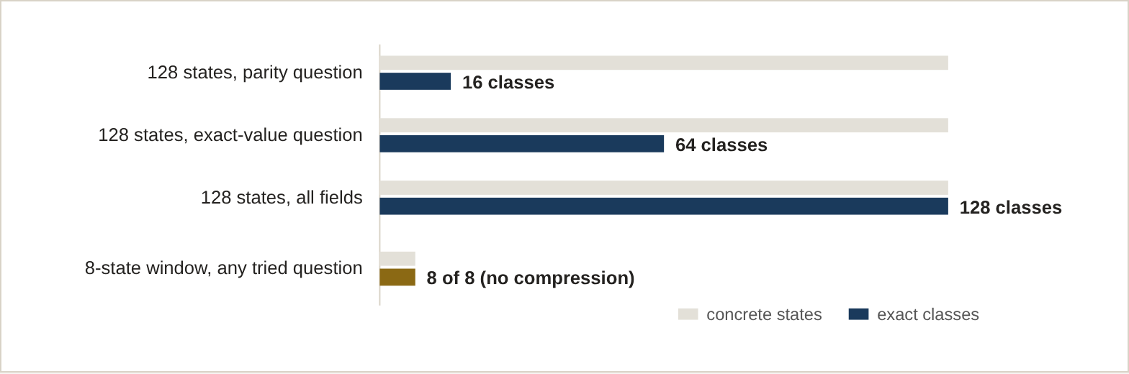
Figure 4. The same 128-state model compresses eightfold, twofold or not at all depending on what is asked of it; a different model resists compression for every question tried. The 8-state bars are drawn on the same scale. [Experimental observation]
The exact-value row is the one that matters in practice. Two states with the same current balance but durable values 0 and 2 become distinguishable after a crash, so no representation can merge them while promising an exact post-crash balance. The implementations are controls on a known idea^{4,5} and are not competitive minimizers.

5.3 Exact composition
For a two-component model, local commutation squares plus one checked boundary rule prove by induction over interleavings that the product of two component summaries is exact. The decomposed check performs 614 comparisons (224 + 70 + 320) against 4,800 for a flat check, and two independent minimizers both find 160 global classes, so the product is the coarsest exact summary for that model and question. [Experimental observation] [Established mathematics] [Developer]
The 614 figure isolates one proof obligation and is not total verification cost. A conventional assume-guarantee verifier with the same ownership and interface could use the same decomposition.^{6,7} What the experiment shows is that exactness can be checked compositionally when the boundary is stated, not that Genesis is required to do so.

6. The Algebra of Authority

6.1 Four states and four operations
Genesis models each permit, a delegable right to perform one action, as being in one of four states, encoded as two polarity coordinates (active, local):
State | Polarity | Meaning
Live | (+, +) | Held and usable by its owner.
Delegated | (+, −) | Still active, but handed to another party to use.
Consumed | (−, +) | Used. The action it authorized has been taken.
Abandoned | (−, −) | Given up without use, for example after a crash.
Four operations move a permit only toward less authority, never back: τ_{del} takes Live to Delegated; τ_{con} takes Live or Delegated to Consumed; τ_{aban} takes Live or Delegated to Abandoned; and τ_{del→con} takes only Delegated to Consumed. Each leaves every other state unchanged. In the research implementation, a 64-bit bitboard reproduced the four-way partition of permits at each of the 45 steps of the test workflow's execution trace. [Verified implementation] [Developer]
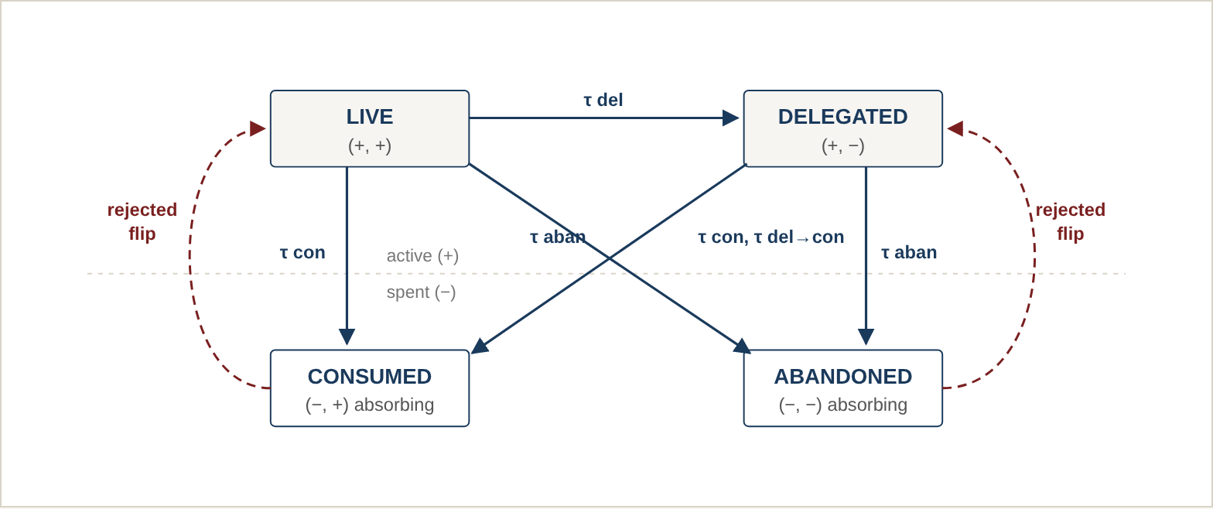
Figure 5. Permitted transitions (solid) never cross the dashed line upward. Treating the active polarity as a two-valued flip that can be inverted (dashed, red) would send Consumed back to Live and Abandoned back to Delegated, minting authority (§10.2). [Established mathematics] [Refuted or unsupported] (the flip)

6.2 Seven distinct transformation maps
Applying the four operations in every possible sequence produces exactly seven distinct transformation maps on the four states, counting the identity (applying no operation). The research record contradicted itself here: its specification and report described a "five-element" algebra, while its raw result file recorded seven. Enumerating every composition of the five starting maps (the identity and the four operations), using only the operator definitions in the source code, gives seven. The five starting maps are pairwise distinct, and composition adds exactly two more. The figure "five" counted the starting maps. Because the seven maps are closed under composition and include the identity, they form what mathematicians call a monoid; nothing below depends on that name. [Established mathematics] [Editorial re-check]
# | Element | Live ↦ | Delegated ↦ | Consumed ↦ | Abandoned ↦
1 | identity | Live | Delegated | Consumed | Abandoned
2 | τ_{del} | Delegated | Delegated | Consumed | Abandoned
3 | τ_{con} | Consumed | Consumed | Consumed | Abandoned
4 | τ_{aban} | Abandoned | Abandoned | Consumed | Abandoned
5 | τ_{del→con} | Live | Consumed | Consumed | Abandoned
6 | τ_{del} after τ_{del→con} | Delegated | Consumed | Consumed | Abandoned
7 | τ_{aban} after τ_{del→con} | Abandoned | Consumed | Consumed | Abandoned

6.3 Why authority cannot be resurrected
The count of seven is a bookkeeping correction. The more useful result is a structural one, which the research record did not state explicitly. Order the four states by how much authority they retain: Live above Delegated, Delegated above both Consumed and Abandoned, with Consumed and Abandoned incomparable.
Proposition 1 (non-resurrection). [Established mathematics] [Editorial re-check]
Each of the seven maps f is deflationary in this order: f(x) ≤ x for every state x. Consequently no finite sequence of authority operations can move any permit to a state that retains more authority than it started with, and Consumed and Abandoned are fixed by every map.
Argument. Each generator is deflationary by inspection of its definition. If f and g are deflationary, then f(g(x)) ≤ g(x) ≤ x, so their composite is deflationary; the property therefore holds for all seven maps. Consumed and Abandoned are minimal, so a deflationary map must fix them.
Two further properties, checked by enumeration, matter for anyone building on the algebra. The set of maps is not commutative: abandoning after delegating-to-consume differs from the reverse order, so the order in which a recovery procedure applies authority operations is part of its meaning. And not every map is idempotent: element 6 applied twice sends Live to Consumed rather than to Delegated, so "apply the same cleanup again" is not automatically harmless. Idempotence of τ_{con} and τ_{aban} individually holds, as a property of their definitions rather than a discovery.
The scope of these statements is the finite four-state model as defined, with its seven maps. They say nothing about a richer authority model, and they are statements about the algebra, not proofs that every path through the Genesis implementation applies only these operations; the latter is what the independent review in §11 tested, within its scope.

7. Case Study: Exact Crash-Cut Work Elimination
This section reports the program's most concrete computational result. It is one case study of the central question in §1, not a definition of what Genesis is, and a separate technical paper is planned to treat it at full length (§15.3).

7.1 The task
A bundling check asks whether two programs are observationally equivalent under every combination of branch decisions and every point at which execution might be interrupted. The test case compares package A, a sixteen-permit workflow whose four binary branch decisions form a tree, against package B, a single-coordinator, 44-step variant of it. With B = 4 branch variables there are 2⁴ = 16 branch assignments. Each execution contains 17 attempt steps, and an interruption can occur after any of the first M = 16 of them or not at all, giving M + 1 = 17 interruption points ("crash cuts") per branch assignment. The number of cases to compare is
2^{B}(M + 1) = 16 × 17 = 272(3)

7.2 The counts, reconciled
The research record used two numbers, 546 and 272, as if they were interchangeable. They count different things. Instrumenting the interpreter entry point and running both verifiers confirms the accounting below. [Verified implementation] [Editorial re-check]
Figure 6 shows the mechanism. The table that follows reconciles the counts.
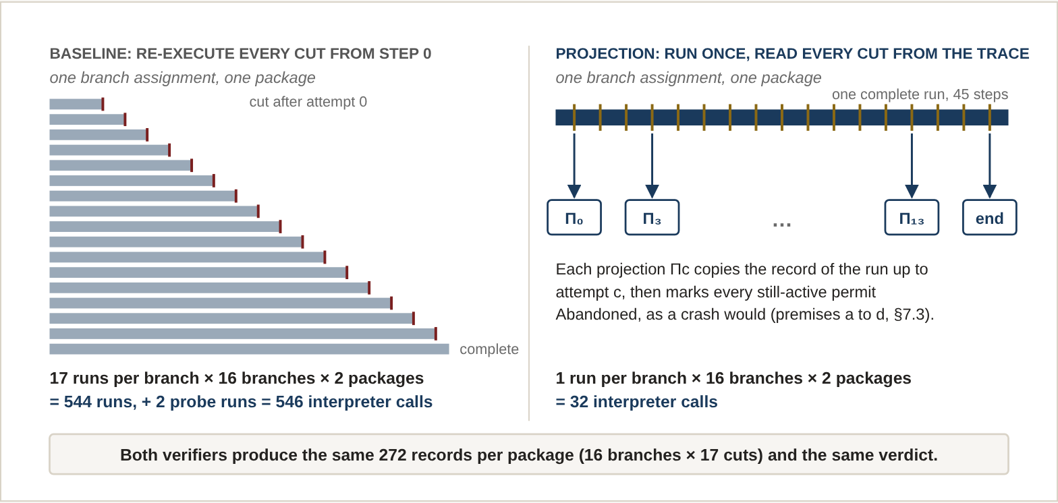
Figure 6. Why 546 interpreter calls become 32. On the left, the baseline re-runs the program from the start for every interruption point (red marks). On the right, one complete run is made per branch assignment and the record at each interruption point (gold marks) is projected from it. Schematic: bar lengths and mark positions are illustrative; the counts are exact. [Verified implementation]
Quantity | Value | Derivation
Branch-and-crash-cut cases to compare | 272 | Equation (3)
Interpreter calls to run both packages at every case from step 0 | 544 | 272 cases × 2 packages
Baseline verifier interpreter calls | 546 | 544 plus 2 probe runs
Optimized verifier interpreter calls | 32 | 2 packages × 16 branch assignments, one complete run each
Cases compared by the optimized verifier | 272 | Projected, not executed
Reduction in interpreter calls | 17.06× | 546 / 32
In general terms, comparing two packages directly costs 2·2^{B}(M + 1) interpreter runs plus any probes, and the projection approach costs 2·2^{B}. The saving is the factor (M + 1) in runs, paid for by the cost of computing and comparing projections. The 17.06× figure is a ratio of call counts. It is not a wall-clock speedup, and §9 shows that the wall-clock effect is smaller.
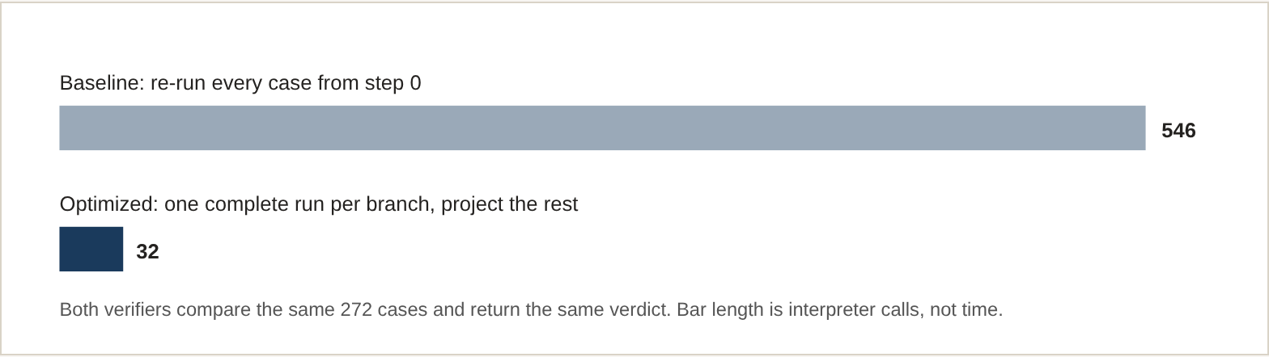
Figure 7. Interpreter calls for the 272-case bundling check, drawn to scale. Valid under the projection conditions of §7.3. [Verified implementation]

7.3 The projection, and when it is exact
Let T(P, b) be the single complete run of package P under branch assignment b, with no interruption, and let i₀ < i₁ < … be the step indices of its attempt steps. Instead of executing the interrupted run for crash cut c, the optimized verifier reconstructs the record that the interrupted run would produce from the complete run's record up to step i_{c}. Write that reconstruction Π_{c}(T(P, b)).
Proposition 2 (prefix-cut projection). [Established mathematics] under premises (a) to (d)
Suppose (a) execution is deterministic given the package, the branch assignment and a fixed scenario; (b) the behavior of the first i_{c} steps does not depend on whether an interruption will occur later; (c) an interruption after attempt c halts the run at that step and moves every permit still Live or Delegated to Abandoned, leaving Consumed permits unchanged; and (d) the compared observation is a function of the prefix of the complete run's record. Then the interrupted run's record equals Π_{c}(T(P, b)) in every compared field.
Argument. By (a) and (b), the interrupted run and the complete run coincide through step i_{c}, by induction on steps. Premise (c) fixes the ledger after the interruption; it is the deflationary map τ_{aban} of §6 applied to every active permit. Premise (d) says the compared fields are read from that prefix.
The proposition is deliberately modest. Its premises carry the content, and the research code encodes premise (d) with rules specific to the test packages: the set of unresolved intents is rebuilt by parsing attempt-label prefixes, and the candidate result is read from the first ledger step that introduces it. The experiment is therefore an executable check that the premises hold for two concrete packages, not a proof for the interpreter in general. [Supported inference] (beyond the two packages)
The check. For each of the 16 branch assignments and 17 crash cuts, the projection was compared field by field with a brute-force interrupted execution. All 272 comparisons matched on package A (reported by the developer) and all 272 matched on package B (editorial re-check, zero mismatches or errors on either). Package B matters because the equivalence verdict compares the two packages' projections to each other; exactness on one side only would not justify the verdict. [Verified implementation] [Developer] [Editorial re-check]
The control. A mutation replaced one call in a region reached only on an untaken branch. The optimized verifier rejected the mutated package with an observational mismatch. The baseline verifier's rejection of the same class of mutation is one of the gates the independent review exercised (§11). [Verified implementation] [Developer]

7.4 What the comparison does and does not exercise
- One compared field is inert. A field that tallies outside-system boundaries by category is copied from the complete run to every cut. Across all 272 brute-force runs it takes a single value, so its equality check cannot discriminate between cuts or packages. The discriminating fields are the result, the unresolved intents, the consumed set, the live-or-delegated set, and the attempt labels. [Editorial re-check]
- The fixture is symmetric in length. All 16 complete runs are 45 steps long. Branch choice changes which calls occur, not how many steps run. An asymmetric fixture has not been tested.
- One configuration. B = 4 and M = 16 only. No scaling claim is made.
- No concurrency or external drift. Both verifiers are deterministic, single-process, and use a fixed scenario. No concurrency, source drift, or unrecorded external effect is modeled.
Governing principle
Useful computation should be performed when necessary, inferred when mathematically justified, and verified according to the precise obligations the program must preserve. On this fixture and under premises (a) to (d), the same 272 observations come from 32 interpreter calls instead of 546. The work eliminated is the repeated re-execution of shared prefixes. Exactness must be re-established for any change to the interpreter, the observation, or the crash model.

8. Measured Quotients and an Incremental Cache

8.1 Observation contracts over the 272 records
The same 272 records can be summarized at different levels, each corresponding to a different observation contract (§5). The research specified seven levels and measured five. The two unmeasured levels have predicted counts in the specification; those predictions are not results and are not reported here. [Experimental observation] [Developer] [Editorial re-check]
Level | What the observer can distinguish | Classes | Note
Q1 | The full canonical record | 272 | Every record distinct.
Q2 | Branch assignment and attempt-label sequence | 272 | No merging.
Q3 | Verification summary | n/a | Specified, not measured.
Q4 | Consumed set and live-or-delegated set | 17 | 272 if each class is also tagged by branch.
Q5 | Recovery kernel: (result, number of unresolved intents) | 21 | Definition-dependent; see below.
Q6 | Future-continuation equivalence | n/a | Specified, not measured.
Q7 | Interrupted or terminal outcome | 2 | One terminal result across branches.
Why Q5 is 21 and not 17. The research report stated 17 and the raw result file stated 21. The code defines Q5 as pairs of (result, number of unresolved intents). Recomputing from the code gives 21: three result values occur, with 1, 4 and 16 distinct counts respectively. The number 17 is a different quantity, the count of distinct unresolved-intent numbers alone, and a third reasonable definition, (result, the set of unresolved intents), gives 34. Because the class count depends on the definition, the only correct statement is the definition together with its count. This is the observation-contract principle of §5 appearing in the project's own bookkeeping. [Editorial re-check]
Storage. The 272 brute-force records total 5,613,593 bytes as canonical JSON (about 20.6 KB each) and 698,716 bytes after general-purpose compression (about 2.6 KB each, a ratio of about 8). This measures ordinary compression of serialized records. It is not the storage cost of any quotient representation, and the class counts above are not storage figures.

8.2 An incremental verification cache
A second experiment memoizes verification work on content identity: each module's analysis is keyed on its name, a hash of its bytes, and a hash of the toolchain; each package-level specification on hashes of its source, its policy and the toolchain.^{10,19} On a six-module package, a cold check analyzed all six modules; an edit to one leaf module re-analyzed one and reused five; a comment-only edit reused the package specification; injecting a forbidden flow from high-security to public data invalidated the package entry and failed closed; and changing the toolchain version invalidated the specification cache. [Verified implementation] [Developer]
This is a bounded test of invalidation over four kinds of change, not a proof that every incremental invalidation is sound, and it is a developer result from the post-preview research line, not a feature of the independently reviewed preview.

9. The Conventional Comparison
A result measured only against a project's own earlier baseline can reflect a weak baseline as much as a strong idea. The research therefore timed five variants of one verification-and-bundling workload on the same host. The recorded figures follow, with the conditions under which they were taken. [Experimental observation] [Developer]
Variant | Mean ms | Median ms | Max ms | Peak alloc. KiB
1. Existing preview baseline | 1,073.10 | 1,195.03 | 1,263.75 | 2,331.38
2. Optimized Genesis (projection and cache) | 239.20 | 236.82 | 252.09 | 1,894.54
3. Unoptimized conventional | 860.20 | 815.63 | 968.35 | 2,699.58
4. Equally optimized conventional | 255.83 | 243.76 | 291.82 | 1,714.22
5. Genesis without projection (cache only) | 734.27 | 732.49 | 757.06 | 2,820.90
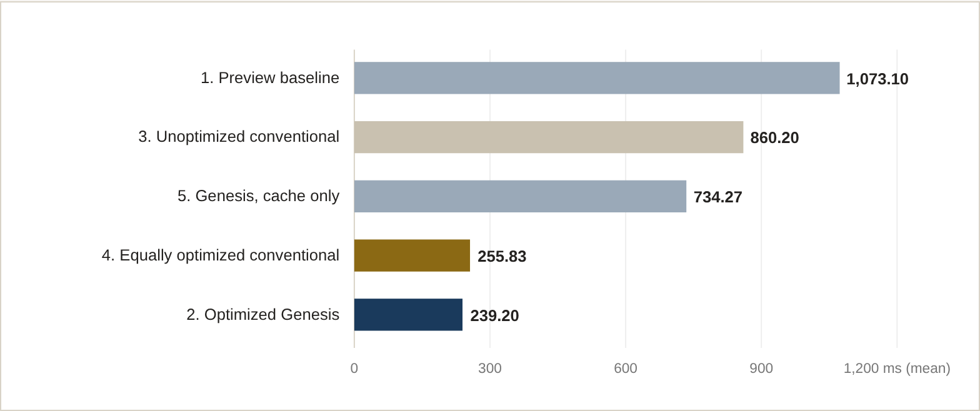
Figure 8. Recorded mean times (lower is better). Variants 2 and 4 use the same projection routine and differ by about 7 percent. Absolute times were inflated roughly six- to eightfold by memory tracing left running during measurement (§9.3); the ratios between variants are the meaningful quantity. [Experimental observation]

9.1 What the numbers support
- The projection removes most of the time. Optimized Genesis ran about 4.49 times faster than the preview baseline and about 3.07 times faster than the cache-only variant. The second ratio isolates the projection within this fixture; the first mixes projection, caching and avoided re-parsing. [Supported inference]
- The saving belongs to the idea, not the language. The equally optimized conventional variant, which calls the same projection routine, reached 255.83 ms against Genesis's 239.20 ms, a ratio of about 1.07, and used less peak memory (1,714 against 1,895 KiB). Applying the projection to the conventional implementation improved it about 3.36-fold. [Supported inference]
This is the expected outcome for an algorithmic saving, and it is the reason this paper calls the result exact work elimination rather than a Genesis speedup. Because variant 4 shares the projection routine, it is an algorithm-matched overhead check, not an independently engineered best-in-class verifier. The case for Genesis therefore cannot rest on speed. If it rests anywhere, it rests on whether stating the preconditions of §7.3 explicitly, as Genesis does, makes such optimizations safer to apply and easier to check. That claim is not tested by this benchmark. [Research hypothesis]

9.2 Three quantities that should not be confused
This paper reports three different kinds of cost, and they support different conclusions.
- Interpreter calls eliminated. The bundling check needs 32 interpreter runs instead of 546 (§7). This is an exact, deterministic count on two fixtures. It measures how much execution was avoided, not how long anything took. [Verified implementation]
- Verification latency. The time to complete that check, measured in the five-way benchmark above. It fell about 4.49-fold against the preview baseline, but an equally optimized conventional implementation using the same projection was within about 7 percent, with no variance reported. [Experimental observation]
- Recovery latency. The time to recover an interrupted run. This paper reports no measurement of it. The projection result concerns verification, not recovery, and RC8's recovery command is defective (§11.5), so no recovery timing from it would be meaningful.
None of the three supports a claim that Genesis outperforms an equally optimized conventional implementation, and this paper makes no such claim. [Refuted or unsupported] (general performance superiority)

9.3 What the numbers do not support
- Absolute times are inflated by the measurement. The benchmark ran Python's allocation tracer throughout the timed loop. Timing the two standalone verifiers with and without it on the editor's host (two runs, ten timed calls per cell after a warm-up) gave about 100 to 133 ms for the baseline and about 30 ms for the projection without tracing, and about 650 to 1,014 ms and 184 to 228 ms with it: an inflation of roughly six- to eightfold. The baseline-to-projection ratio stayed between about 3.3 and 4.5 in every run, with and without tracing. [Experimental observation] [Editorial re-check]
- Five iterations, warm caches. Each variant ran five times; caches were cold on the first iteration only, and the mean averages cold and warm runs together. The figures are neither cold-start nor steady-state.
- No variance. The column the benchmark labeled "p95", shown above as Max, is the maximum of five samples, not a percentile. No confidence intervals exist, so the 7 percent difference between variants 2 and 4 is not established as meaningful. [Refuted or unsupported] (any claim that Genesis is faster than variant 4)
- No energy measurement. The benchmark's energy column is mean seconds multiplied by an assumed 15 watts. It is arithmetic, not measurement, and is omitted here.
- No crossover claim. A recorded "reuse crossover" value of 1 is a constant in the benchmark code, not a computed result.
- Separate measurements are not combined. An earlier single-call timing of the two verifiers (103.55 ms against 25.79 ms, about 4.01×) is a different measurement from the five-way means.

10. What the Research Disproved
A research program that reports only its successes teaches very little. The negative results below are kept because the surviving design is defined by what they ruled out, and because a reader attempting the same directions would otherwise be likely to repeat them.

10.1 Early counterexamples
Attractive idea | Counterexample | What the research kept
Provenance edges explain a result | In y := x OR w, a path exists from x, but x is not a but-for cause. | Explanations name their mode and context.
Local contracts compose | Two actors each run if n == 0 then n := 1 and each emits a grant; interleaving yields two grants against a limit of one. | Composition needs atomicity or an interference condition.
A durable intent settles an external effect | The lost acknowledgment (Figure 1). | Unresolved outcomes are first-class.
Compensation inverts an effect | A refund is a new effect; the charge remains in history. | Compensation carries its own uncertainty.¹³
Partial-order concurrency always shrinks traces | n writers under a fixed lock order are effectively totally ordered. | No blanket compression claim.⁸
A recursive or "fractal" interface is faster | With identical summaries and invalidation, a complete binary tree revisits the same h + 1 ancestors under either labeling. | Interface repetition alone yields no advantage; geometric claims need a matched control.
A parent summary of success or failure suffices | Two children with identical failure reports differ in possible external state. | Boundaries must carry unresolved effect identity.
[Refuted or unsupported] (each idea, under the stated assumptions). These are mathematical examples, not executed tests.

10.2 Three shortcuts tested in software

The invertible authority flip
Treating the active polarity of §6 as a two-valued flip that is its own inverse would make abandoning twice equal to doing nothing. It would send Abandoned back to Delegated and Consumed back to Live, minting authority. The flip is not deflationary, so it is not one of the seven maps of Proposition 1, and it violates the one-way property authority depends on. The algebraic convenience that made it attractive, reversibility, is precisely what authority must not have. [Refuted or unsupported]

Symmetry-based sampling
On the symmetric test fixture, all 16 branch assignments (the vertices of a four-dimensional cube) have identical step count (45) and identical consumed-permit count (19), a genuine structural invariant. Testing one representative per symmetry orbit, grouped by the number of true branches, then falsely accepted an asymmetric mutation placed on a branch that was not a representative. The full projection verifier rejected it. Symmetry of cost does not imply symmetry of faults, and a sampling method that can certify a program it has not fully examined is unsound as verification.⁹ [Refuted or unsupported] [Developer]

A helical law for crash cuts
Modeling crash cuts as phases on a cycle of length 17 and composing them by addition modulo 17 contradicted the absorbing crash law on all 256 tested pairs. A second interruption after a first has no further effect; modular addition would produce a different cut. The arithmetic composed cleanly. The program semantics it was meant to represent did not. [Refuted or unsupported] [Developer]
Principle drawn from the negative results
Resemblance is not equivalence. A visually or algebraically appealing structure (a symmetry, an inverse, a cycle) is evidence of nothing about program behavior until it is checked against the obligations the program must preserve. In all three cases the structure was real; what it failed to preserve was meaning. None of these results shows that no alternative optimization of the same kind exists; each is stated with its exact scope.

11. Practical Genesis: The Restricted Preview

11.1 What it is
The surviving implementation is a restricted, source-driven toolchain over a finite subset of two package grammars. It derives its verifier from canonical source and policy bytes, checks recorded executions against the derived expectation, tracks delegated authority in the four-state model, supports interrupted runs with recovery witnesses, and keeps locally authenticated custody of its history. Its command surface is seven commands: check, run, verify, recover, audit, keygen and rotate-keys. It is a toolchain for one user on one host. It is not a general-purpose language, not a distributed system, and not a deployed safety system.
Sections 11.4 to 11.7 show a real program in this language as run by the independent reviewer, what its recovery did and did not establish, a second program the reviewer wrote from the documentation, and a conventional comparison.

11.2 Independent acceptance
Throughout this paper, "independent reviewer" means a separate AI agent, recorded as Kimi K, that did not build Genesis and worked from a clean install in the Foundation's own environment. It is not an independent human research team or another institution, and its work is a check, not a replication.
The independent reviewer ran a clean-room adversarial review of the frozen eighth release candidate (RC8): a byte-identical offline rebuild of the distribution, matching hashes for every installed module, a nine-step product workflow, and retests of five counterexamples that had made the previous candidate not ready. The verdict was conditionally ready for restricted private preview: six gates passed, six were conditional, none failed. This is not an acceptance of a general Genesis language, and it does not cover the later projection and cache experiments of §7 to §9. [Verified implementation] [Independent]
Gate | Status | What was independently exercised
01 Command surface | Conditional | All seven commands on both grammars, plus the workflow; restricted to the frozen grammar.
02 Offline install | Pass | Pinned distribution installed offline; byte-identical rebuild; all module hashes matched.
03 Source- and policy-bound retries | Pass | A changed branch or policy was rejected; a retry with reordered input returned the stored record.
04 Digest binding | Pass | Policy and source digests present across certificates and recovery.
05 Delegated authority and recovery | Conditional | Four-state authority, an interrupted run, witness-based recovery, replay rejection.
06 Bundling | Pass | All 272 branch-and-crash-cut cases verified; an untaken-branch mutation rejected.
07 Information flow | Conditional | Direct, implicit-branch, transformed and unpermitted-declassification leaks rejected.
08 Rotation history | Conditional | Full history authenticated; depends on an external epoch floor and single-host durability.
09 Key custody | Conditional | Local custody and identity checks; signed rotation claims; single-user local directory assumed.
10 Active lease | Conditional | Lease guard and monotonic fencing; not a distributed-consensus guarantee.
11 Adversarial review | Pass | Completed; all blockers from earlier candidates remediated.
12 Boundary documentation | Pass | Single-host, epoch-floor, migration, race-condition and external-effect boundaries documented.
Gate 06 is the same 272-case check that §7 re-derives. It is a checked property of the frozen preview, using the preview's own verifier, and is distinct from the later 32-call optimization.

11.3 The correction history is part of the result
The previous candidate failed review on five reproduced defects in key custody and audit. Each became a regression test and was retested against the installed RC8 distribution. Two boundaries remain documented: data stores rotated under the earlier candidate fail closed rather than migrating, and one local race condition is accepted within the single-user threat model. The review's limits matter as much as its verdict: fourteen process-abort interruptions across seven key-rotation boundaries left the key-rotation state consistent (this concerns key custody, not recovery of workflow tasks), which is evidence about a process being killed and not about a machine losing power. Security-relevant implementation detail is kept here at the level of reviewed behavior. [Verified implementation] [Independent]
The correction history did not end with the acceptance review. A later independent developer evaluation of the same frozen release found a defect that the acceptance review had not: the recover command can report success for a recovery that failed (§11.5). It is recorded here, alongside the earlier defects, for the same reason.

11.4 A program, independently executed
The program below is the preview's own recovery example, a six-module logistics workflow, run on 24 October 2026 by the independent reviewer from a clean install of the frozen RC8 distribution. The listing is the complete agent module, which holds the two required entry points: solve, the workflow, and resume_unknown, the recovery procedure. The other five modules (planner, compliance, coordinator, executor and status) are summarized after it, and the status module is shown in full because recovery depends on it. [Verified implementation] [Independent]
Listing 1. agent.gsp6, complete module (2,390 bytes; SHA-256 5fdd3fa38a5d5f6a13b261443c390ab4e0cb770fe0af46e5acc21fce6bb1e5d8). Package identifier 2716ebc78d1eec0087402ff84d3951aa2bf5c558f13298cce107df79dce10ffa.
!gsp 0.6
!module agent
!version 1
!import planner 1
!import compliance 1
!import coordinator 1
!import executor 1
!import status 2
@role solve/entry
fn solve(shipment_id, depth, policy, root_relation) -> SolveOutcome issues(P_manifest, P_hop_primary, P_hop_secondary, P_hop_escrow, P_park_hold, P_cut_sel) {
@role solve/planner/call
let plan_word = call planner.plan_three_inv_dag(shipment_id, depth);
@role solve/policy/cond
guard_policy policy on_false -> return ThreeInvPolicyDenied;
@role solve/actorA/attempt
attempt effect_a consume(P_manifest) on_uncertain -> produce(ManifestUncertain) on_rejected -> return ManifestRejected;
@role solve/compliance/forward_primary
call_forward compliance.vet_primary(shipment_id) forward(P_hop_primary) -> (SharedCommitUncertain, SharedCommitRejected);
@role solve/compliance/forward_secondary
call_forward compliance.vet_secondary(shipment_id) forward(P_hop_secondary) -> (SharedCommitUncertain, SharedCommitRejected);
@role solve/compliance/forward_escrow
call_forward compliance.vet_escrow(shipment_id) forward(P_hop_escrow) -> (SharedCommitUncertain, SharedCommitRejected);
@role solve/actorA/park
park consume(P_park_hold) on_committed -> produce(ThreeInvParkCandidate) on_rejected -> noop;
@role solve/actorB/select
bselect consume(P_cut_sel) root(root_relation) -> (selected, stale_rejected);
@role solve/join
join_branches require_all_live forbid_untaken_candidates;
}
@role resume/entry
fn resume_unknown(record, hist_proof, witness) -> ResumeOutcome {
crash_cut abandon_live clear_candidates;
restart_cut issue(R_read1, R_read2) clear_candidates;
@role resume/load/match
load_decode record consume(R_read1) on_unknown -> reset_produce(ThreeInvLoadedUnknown) on_completed -> return ThreeInvCompletedVariant;
@role resume/migrate/arm
migrate_v1 record requires(historical_proof) on_ok -> reset_produce(ThreeInvMigratedV2) on_missing -> return Rejected:no_hist_proof;
@role resume/recheck/match
recheck_multi record consume(R_read2) fresh_from(R_read1) effects(effect_a, effect_shared_commit_inv1, effect_shared_commit_inv2, effect_shared_commit_inv3) -> (ThreeInvCurrentCand, WitnessManifestOnly, WitnessPartialCommits, WitnessAllThreeCommits);
@role resume/forbidden
forbid unknown_to_completed, effect_replay, authority_mint, read1_reuse, unauthenticated_persist;
}
Read as a workflow, solve issues six permits, consults a planner that is forbidden from side effects, checks a policy, attempts one outside effect (effect_a, the shipping manifest) by consuming one permit, and then delegates three permits across a chain of modules (compliance to coordinator to executor), where each is consumed only by the final call that actually attempts an effect. Every line beginning @role names the line that follows; those names become the step labels in the recorded trace and in verification. resume_unknown is the recovery procedure: at an interruption it abandons every permit still Live, issues two fresh read permits, decodes the stored record, migrates it if the record format has changed, and rechecks which outside effects the evidence actually covers. Its last line forbids, among other things, treating an unknown outcome as completed, replaying an effect, and minting authority.
Listing 2. status.gsp6, complete module. Status code 5 means Unknown under record format v1; recovery may migrate it to v2 only with historical proof.
!gsp 0.6
!module status
!version 2
@role status/record/form
fn parse_three_inv_record(raw_record) -> RecordValue {
forbid unbounded_int_cast, unknown_to_completed;
}
@role status/table/v1
table v1 { 5 -> Unknown ; 8 -> Completed }
@role status/table/v2
table v2 { 8 -> Completed ; 9 -> Unknown }
@role status/decode/rule
fn decode_three_inv_version(raw_record) -> DecodedStatus {
forbid foreign_version_decode, completed_in_resume;
}
@role status/migrate/rule
migrate v1:5 -> v2:9 requires historical_proof yields ThreeInvMigratedV2
The remaining modules are short. planner declares a pure planning function. compliance has three vetting functions, each requiring its own permit and forwarding it onward. coordinator routes two of those on a named branch to either a shared-ledger commit or a rail shipment. executor holds the two functions that attempt outside effects. All six modules were checked and run as a single package.

Commands and captured output
The reviewer ran the commands below on Windows with the installed preview's own Python interpreter. A local signing key is created first and passed to run, verify and recover; key handling and the audit command are not shown. The run command deliberately interrupts the workflow after its first effect attempt. Output is reproduced from the reviewer's captured results; long digests are shortened and custody fields are omitted.
genesis-preview check --pkg examples/recovery
genesis-preview run --pkg examples/recovery --wal-db state.sqlite --key-file key.json \
--task-id T1 --crash-after-attempt 0 \
--emit-record interrupted.json --emit-cert interrupted.cert.json
genesis-preview verify --pkg examples/recovery --record-file interrupted.json \
--cert interrupted.cert.json --key-file key.json
genesis-preview recover --pkg examples/recovery --wal-db state.sqlite --task-id T1 \
--key-file key.json --epoch-floor 1 --emit-record recovered.json
check exit 0
{"accepted": true, "package_id": "2716ebc7...0ffa"}
run exit 0
{"accepted": true, "result": "ManifestUncertain", "step_count": 4,
"wal_custody": {"anchor_epoch": 1, "status": "INTERRUPTED_UNCERTAIN"}}
verify exit 0
{"accepted": true, "all_nine_accepted": true, "error_code": "ok"}
recover exit 0
{"accepted": true, "anchor_epoch": 2, "error_code": "ok", "verb": "recover"}
The first three results are what they appear to be. check accepted the source, including its authority typing. run stopped where asked: one permit consumed, five still Live, and the manifest effect recorded as unresolved rather than done. verify re-derived the expected behavior from the source and policy and accepted the recorded run on all nine of its judgments, bound to the exact source bytes. Those judgments establish that the record is a valid trace of this source under this policy; as §11.5 shows, a valid trace is not the same thing as a successful outcome. The fourth result is not what it appears to be, and §11.5 explains why. [Verified implementation] [Independent]

11.5 Recovery: what the interpreter accepted, and what the command reported
Three different things can be meant when a run or a recovery is said to have "succeeded", and this paper keeps them apart throughout.
Level | What it means | What the evidence in this paper establishes
1. Valid execution trace | The verifier accepts a record as a faithful trace of the program's source under its policy. | Established for the interrupted run and for both recoveries in Figure 9, including the failed one. It says nothing about whether the outcome was the intended one.
2. Internally consistent recovery | After an interruption, every permit is accounted for, the stored record is correctly decoded, and the evidence claims no more outside effects than were actually unresolved. | Established only through the reviewer's reference procedure, on one program, with four negative controls. Not established by RC8's recover command.
3. Completion of the external task | The outside world actually did what was requested: the manifest was received, the shipment moved. | Not established by anything in this paper. The relevant effect remains explicitly unresolved, and only the receiving system can settle it.

A defect in the RC8 recovery command
The recover command above reported success and advanced the custody epoch from 1 to 2. The recovery it actually performed had failed. The independent investigation found that the command's wrapper (the host code that prepares the recovery call and stores its result) supplied a fixed status code that this program's status table does not define, re-ran the interrupted workflow to completion instead of resuming from the recorded interruption point, and then stored the result as recovered, because its only test was that the recovery trace was well-formed. The recovery procedure itself correctly rejected the record (Rejected:code, after 23 steps), left one recovery permit unused, and abandoned none of the interrupted permits. The wrapper nevertheless marked the task recovered, marked its outbox entry committed, and locked it against further recovery. RC8's recover command therefore cannot be taken as evidence that a task was recovered. [Refuted or unsupported] (success status as proof of recovery) [Independent]
The investigation located the defect in the wrapper, and found that the interpreter and verifier behaved correctly when given correct inputs. The reviewer wrote an independent reference procedure that calls the same interpreter and verifier with the task's actual inputs: the real interruption point, the status code the program defines, the actual unresolved effect, and authenticated receipts. On the unmodified program it produced the nine-step trace below, which all nine verifier judgments accepted. Against deliberately bad inputs (an undefined status code, missing historical proof, an empty witness, and a witness claiming more effects than were unresolved) the same reference refused to commit and did not advance the epoch. The shipped wrapper, whose only test is that the trace is well-formed, would have committed three of those four. [Verified implementation] [Independent]
What this does and does not establish. It establishes that the tested interpreter semantics are correct for this program and these controls: given the right inputs, the language reaches the right state and rejects the wrong ones. It does not establish end-to-end recovery correctness for RC8. Three facts keep the two apart. First, RC8 as shipped has no command that performs this recovery correctly; the correct result was reached only through the reviewer's own reference procedure, which has not itself been independently reviewed. Second, the verifier's nine judgments test whether a record is a valid trace of the program, not whether recovery succeeded: the failed recovery above was also accepted on all nine, which is why the verifier could not catch the wrapper's error. Third, the evidence covers one shipped program, one reviewer-written program and four negative controls. Whether recovery is correct end to end therefore depends on the wrapper being fixed and the whole path being re-tested (§15.2), and the paper treats it as unestablished until then. [Supported inference] (interpreter semantics) [Refuted or unsupported] (end-to-end recovery correctness in RC8)
Figure 9 sets the two recoveries side by side; Table 11.5 then gives the reference recovery step by step.
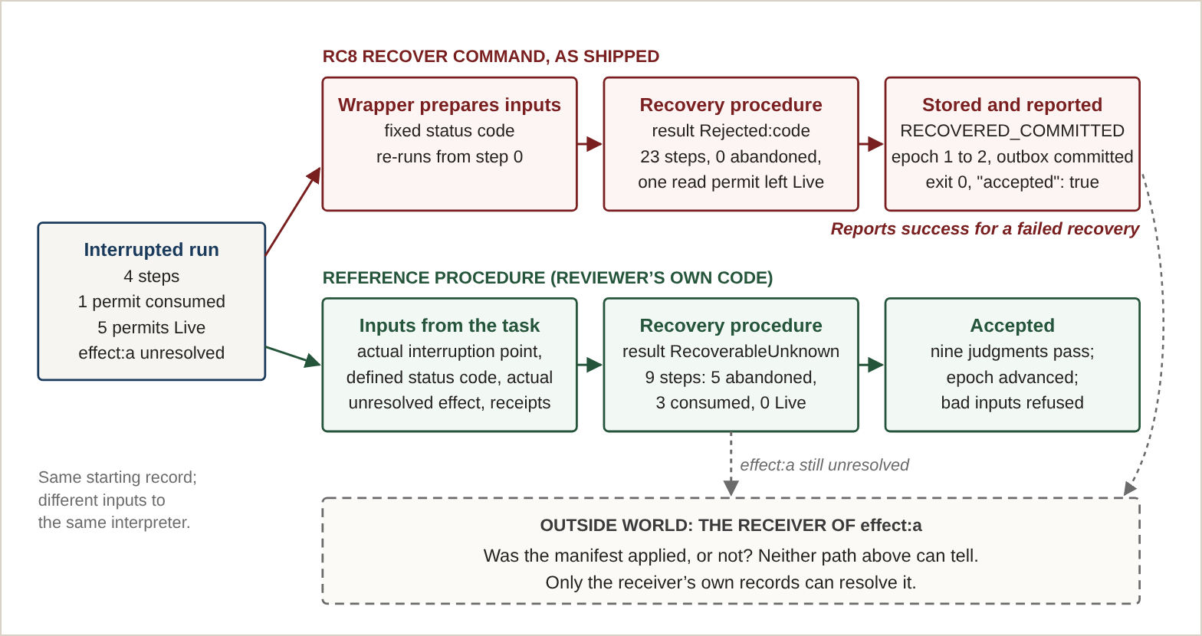
Figure 9. One interrupted run, two recoveries. Top: the shipped recover command feeds the recovery procedure the wrong inputs, the procedure correctly rejects them, and the wrapper stores and reports the rejection as a success. Middle: the reviewer’s reference procedure gives the same interpreter the task’s real inputs and reaches RecoverableUnknown. Bottom: in both cases the outside effect remains unresolved; recovery makes the state consistent but does not learn what the receiver did. Values are from the independent recovery investigation (§11.5). [Verified implementation] [Independent]
Step | Label | Branch taken | Live | Consumed | Abandoned | What happened
0 | solve.start | - | 6 | 0 | 0 | All six permits issued and Live.
1 | solve.planner | plan | 6 | 0 | 0 | Pure planning call; no authority used.
2 | solve.policy | true | 6 | 0 | 0 | Policy guard passes.
3 | solve.attempt:P_manifest | uncertain | 5 | 1 | 0 | Manifest effect attempted; reply uncertain.
4 | env.crash | - | 0 | 1 | 5 | Interruption: the five unused permits move to Abandoned.
5 | resume.restart | - | 2 | 1 | 5 | Two fresh read permits issued for recovery.
6 | resume.load | unknown_v1 | 1 | 2 | 5 | Stored record decoded as Unknown under status table v1.
7 | resume.migrate | v1_to_v2 | 1 | 2 | 5 | Record migrated to v2, which requires historical proof.
8 | resume.recheck | moved_witnessed_a | 0 | 3 | 5 | Witness covers effect a only; no authority left Live.
Table 11.5. Language-level recovery of the interrupted run (reference procedure, unmodified program). Counts are permits in each authority state after the step. One outside effect, effect:a, remains unresolved from step 3 to the end.
What RecoverableUnknown means
The recovered result is RecoverableUnknown, and it is a deliberately modest claim. It says the program has been brought to a consistent, checkable state: every permit is accounted for (one consumed before the interruption, five abandoned by it, both recovery reads consumed, none left Live), the stored record was decoded and migrated with the required proof, and the evidence covers exactly one outside effect, the manifest. It does not say the manifest was delivered, that the shipment proceeded, or that the business task is complete. The outcome of effect:a is still unknown, and the record says so. Resolving it requires information from the receiving system, which no local procedure can manufacture. This is the lost-acknowledgment case of §2.1, handled the way the observation frame of §4 requires.

11.6 An independently written program, and a conventional comparison
To test whether someone other than the developer can program in Genesis from its documentation alone, the reviewer also wrote a new six-module program, a cold-chain customs and escrow clearance workflow, using only the preview's language, first-program, command and example guides. It exercises three vetting gates, two independent routing branches, and information-flow annotations that none of the shipped examples use. Its source is not reproduced here. [Verified implementation] [Independent]
Test | Observed result
Static check with information-flow analysis | Accepted; information-flow check performed and passed
Default run, with record and certificate | Result CryoVaultUncertain, 20 steps
Verification of record and certificate | Accepted on all nine judgments
Policy denied | Result ColdChainPolicyDenied, 3 steps
First effect rejected by its receiver | Result ManifestRejected, 4 steps
Alternate branch routing | Result CryoVaultUncertain, 20 steps, routed through the ambient-hold path
Interrupted after the second effect attempt | Status INTERRUPTED_UNCERTAIN, 9 steps
Recovery command | Reported RECOVERED_COMMITTED; subject to the defect in §11.5, so not evidence of recovery
Adversarial probes. Twelve deliberate misuse attempts were all rejected with specific errors: malformed source and an unused permit; reuse of a permit already delegated; a direct leak of protected data to a public output; a one-line comment edit and an added annotation after certification; verification under the wrong key; a tampered ledger inside a recorded run; a duplicate task identifier; a retry that changed its inputs; recovery of an already completed task; repeated recovery of an already recovered task; and a key rotation onto a file the tool did not own. [Verified implementation] [Independent]
Conventional comparison. The reviewer also wrote the same workflow as an ordinary Python program, which passed its five test assertions. The comparison is about where guarantees live, not about speed, and no timing comparison was made. Each guarantee below can be written in Python by hand; the difference is that RC8 enforced it, in the reviewer's tests, for every program its grammar accepts, from the source, without the programmer writing it again. These are observations about the accepted RC8 grammar under its single-user, single-host threat model; they are not claims about programs the grammar rejects, about other versions, or about attackers outside that model.
Property | Genesis RC8 (observed in tested programs) | Ordinary Python version
Unused or reused authority | Rejected before running by the type checker, in the tested cases | Possible unless the programmer adds checks
Unconfirmed outside effects | Recorded as unresolved in every tested run | Represented only if the programmer models them
Checking a recorded run | Nine separate judgments against the source | No equivalent unless written separately
Source or policy changed after the fact | Detected by digest mismatch at verification | Not detected unless built in
Changed retry, or replayed recovery | Rejected by request identity and task state | Depends on the programmer's idempotency design
Loops, arithmetic, real network calls | Not available (§11.7) | Available
The last row matters as much as the others. The Python version can do things Genesis cannot. What RC8 currently offers is a narrower language in which a specific set of guarantees comes with the toolchain, within its accepted grammar and tested threat model. [Supported inference]

11.7 What the language can and cannot express today
What a programmer can write. A package of modules, each with versioned imports; a required workflow entry point and a required recovery entry point; explicit permits that are issued, delegated across modules, consumed by effect attempts, and abandoned at interruption; named boolean branches; status tables with versioned record formats and migration rules; prohibitions the checker enforces (no side effects in a planner, no unknown-to-completed conversion in recovery); and information-flow annotations. Every line can carry a role name that appears in the trace and in verification.
What a programmer cannot write. The language is a finite workflow-specification language. It has no loops, no general arithmetic or expressions, and no direct network or file input and output; the reviewer's attempt to add a loop was rejected by the parser. Outside effects are simulated tokens rather than calls to real carriers, banks or escrow services. Both entry points are mandatory even for programs that do not need recovery.
Rough edges found by the reviewer. The information-flow annotations work but are not documented, and branch names that do not follow an internal naming pattern must be declared explicitly once any annotation is used. Running a program with a syntax error, instead of checking it first, prints an internal error trace rather than a structured message. Local recovery cannot undo physical outside effects, and it cannot detect a whole-file rollback of its own database unless a known epoch number is retained separately.
None of these limits is unexpected for a restricted preview, and none affects the verification results above. Together they mark the distance between the preview and a general-purpose language; closing that distance is listed in Figure 10 as a hypothesis, not a result.

12. Relation to Prior Work
Almost every ingredient in Genesis is established, and the paper does not present any of them as new.
- Exact summaries. The observation-relative summary is the quotient of a labeled transition system by a bisimulation or trace-equivalence relation,² computed by partition refinement,^{4,5} and Theorem 1 is the completeness condition of abstract interpretation in its simplest form.¹
- Composition. Compositional exactness arguments follow assume-guarantee and rely-guarantee reasoning.^{6,7}
- State-space reduction. Partial-order reduction and abstraction refinement in model checking eliminate redundant exploration by proving that paths or states are interchangeable;^{8,9} the symmetry-sampling failure of §10.2 is the failure such methods are designed to avoid.
- Reuse of computed results. Memoization, partial evaluation and content-addressed incremental builds all eliminate repeated work;^{19,20,10} the projection of §7, which answers questions about every prefix of an execution from a single run, is closest in spirit to these.
- Recovery and external effects. Write-ahead logging and repeatable-history recovery,³ idempotency keys, outbox tables and event logs,^{12,14,15,16} and compensating transactions¹³ are standard practice. Systematic exploration of crash states has found real consistency bugs in storage software,²¹ which is also the clearest reminder that a finite set of tested interruptions is not a proof.
- Authority. Delegable, non-forgeable authority follows the capability tradition,^{11,22} and authority as a resource that cannot be duplicated or revived parallels linear types.²³
- Authenticated history. Hash-linked structures for tamper-evident records²⁴ underlie the separation of compact state from verifiable evidence.
- Limits on distribution. Agreement among unreliable hosts carries known impossibility results,²⁵ and exactly-once effects at a non-cooperating receiver cannot be guaranteed by the caller alone;¹⁵ both bound what Genesis can claim.
- Verified systems. Formally verified kernels and compilers show that strong guarantees are achievable for real software, and also that each guarantee covers only what its specification states.^{26,27}
The integration hypothesis
Each mechanism above exists elsewhere. The hypothesis that would distinguish Genesis is about their combination: that deriving execution, verification, authority accounting, recovery and audit from one source-level semantics yields guarantees that are hard to obtain by composing separate tools, such as a workflow engine, a capability library, an event log and an external verifier. Specifically:
- a single definition of state, shared by the run, its verification, its recovery and its audit;
- authority accounting that is part of the program's meaning, so that interruption cannot silently restore or lose a permit;
- checks derived from each program's source rather than written separately for each program; and
- work elimination and summaries bounded by explicit observation contracts, so that a shortcut states what it preserves.
This is a hypothesis, not a result. It would be refuted if a composition of existing tools delivered the same guarantees with comparable effort and comparable error rates. The recovery defect of §11.5 is relevant evidence in both directions: the failure occurred exactly at the seam between the language and its host wrapper, the kind of seam the hypothesis says one semantics should remove, yet it occurred inside Genesis's own toolchain. [Research hypothesis]
What Genesis claims is narrower: a joint treatment, in one restricted toolchain with independent review and preserved counterexamples, of source-derived verification, delegated authority with a non-resurrection property, uncertain external effects, authenticated recovery, and observation-specific evidence. Whether that combination is new is a separate question, answered neither by this paper nor by any benchmark in it. A formal novelty and prior-art review has not been completed.

13. Broader Implications
The results suggest possible uses. They do not demonstrate them. Figure 10 places every capability discussed in this paper by the strength of its evidence; the table after it separates what the evidence shows in each application area from what remains a direction.
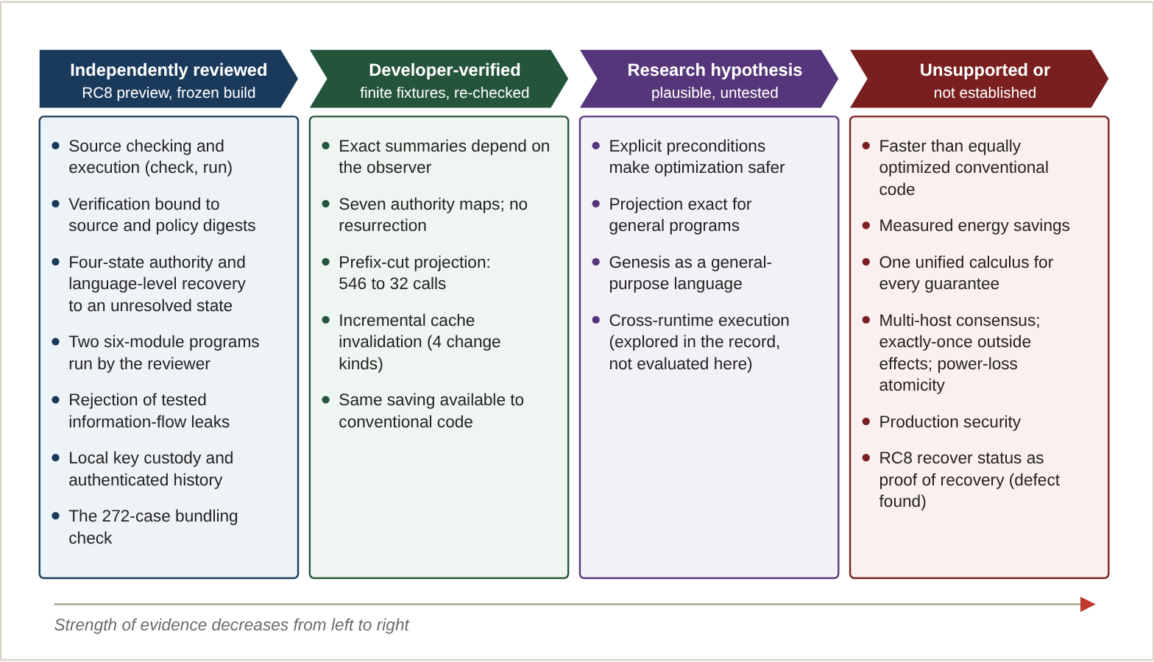
Figure 10. What Genesis does today, what has been shown on finite fixtures, what is proposed, and what the evidence does not support. Each item is tied to a row of the claims ledger (Appendix A).
Area | What the evidence shows | What would have to be shown
Verified software execution | Source- and policy-bound certificates and replay rejection in a single-host preview (§11). | Use on programs outside the frozen grammar; independent use by other developers.
Fault-tolerant workflows | Explicit unresolved outcomes; recovery from process aborts in tested cases; language-level recovery to an explicitly unresolved state (§11.5). | A corrected recovery command; power-loss behavior; integration with real outside services and their contracts.
Computational optimization | A 17× reduction in interpreter calls on one fixture, with exactness checked (§7). | Generalization across programs, branch counts and interruption counts; a proof or property-based testing.
Secure automation | A deflationary authority algebra (§6); rejection of information-flow leaks in tested forms. | Whole-system security review beyond a single-user threat model.
Distributed agent coordination | Nothing yet. Leases and fencing are bounded and local. | A consensus-aware design and its own evaluation.
Logistics and complex operations | Nothing yet beyond test workflows whose branch names (air, sea, rail, satellite) are drawn from logistics. | A controlled pilot against a real operational workload.
Auditable AI-assisted development | A research record in which AI-produced claims were independently reviewed and several were corrected (§11.3, Appendix D). | A repeatable method, tested on other projects.
Data-center efficiency | Nothing. No energy has been measured. | Measured energy on representative workloads against equally optimized baselines.
One implication is already supported. The research record itself contained four reporting conflicts (the number of authority maps, the Q5 count, the 546 and 272 figures, and several specification-versus-result mismatches) that were caught only because claims were labeled, sources were preserved, and numbers were recomputed from code. For a program carried out largely by AI agents, that is not incidental. It is evidence that the discipline Genesis applies to computation, stating what each summary preserves and re-checking it, is also the discipline AI-assisted research needs. [Supported inference]

14. Known Limitations and Threats to Validity

Stated directly
- Independence is between AI agents. The independent review and the independent developer evaluation were performed by a separate AI agent in the owner's environment, not by a human team or another institution. They are not independent replication.
- Not publicly reproducible yet. The RC8 distribution, the research fixtures and code, and the reviewer's test artifacts have not been publicly released, so third parties cannot currently re-run the experimental and implementation results. Only the mathematics can be checked from this paper alone.
- No independent replication of the developer experiments. The projection, quotient, cache and benchmark results were produced and tested by the developer. The editorial re-checks use the same code and the same class of host, and are not replication. Only the RC8 preview has been independently reviewed.
- Two fixtures, one configuration. Work-elimination results rest on two packages with B = 4 and M = 16, symmetric in trace length. No scaling claim is made.
- Fixture-specific projection rules. The projection code encodes premise (d) of Proposition 2 with rules specific to the test packages. There is no general proof for the interpreter.
- Simulated effects. "Equivalent" means equal in the compared fields of a deterministic simulated record, not equal behavior of a deployed system. All external effects are simulated.
- Measurement weaknesses. Five iterations, warm caches after the first, allocation tracing during timing, a maximum labeled as a percentile, no variance, and an assumed power constant.
- Single-host, single-user scope. No guarantee covers concurrency, distributed consensus, exactly-once effects at outside services, or hardware power loss.
- Unmeasured levels. Two of seven specified quotient levels have no implementation or measurement.
- Proofs are by hand. Theorems 1 and 2 and Propositions 1 and 2 have short arguments that have not been machine-checked.
- Provenance. Speaker-attributed records of the original research conversations were not available for this paper. The repository documents how the work evolved step by step; the paper does not attribute individual techniques to particular participants.
- Novelty. No formal prior-art review has been completed.
- The RC8 recovery command is defective. It can store and report a failed recovery as successful (§11.5). Recovery claims in this paper rest on the language-level reference procedure, not on that command.
- A restricted language. No loops, general arithmetic or real input and output; outside effects are simulated (§11.7).
These limits are part of the research record. They are not reasons to discard the supported results, and the supported results are not reasons to set the limits aside.

15. If This Paper Is Wrong, and What to Test Next

15.1 Falsification criteria
The central claims should be considered weakened or refuted if any of the following is found:
- A projected record differs from the record of an actual interrupted run, on any program that satisfies premises (a) to (d) of Proposition 2.
- Any sequence of operations accepted by the Genesis implementation moves a permit from Consumed or Abandoned to an active state.
- The 3.07-fold gain over the cache-only variant disappears under independent re-measurement with variance reported and without allocation tracing.
- The cost of computing and checking projections grows fast enough with program size, B or M that the net saving vanishes on realistic programs.
- A conventional implementation can state and check the same preconditions with comparable effort and comparable error rates, which would leave the Genesis architecture without a distinct contribution.

15.2 The research agenda
- Generalize the projection. Either prove Proposition 2 for a stated interpreter semantics, or test it with generated programs against the interpreter, including asymmetric branches and prefix-dependent external counts.
- Sweep the parameters. Vary B and M and confirm that interpreter calls follow 2·2^{B}(M + 1) + 2 for the baseline and 2·2^{B} for the projection.
- Measure properly. At least 30 runs per variant, cold and warm reported separately, memory measured in a separate run, variance reported, and an independently written conventional implementation alongside the algorithm-matched one. Measure energy or report none.
- Test the real hypothesis. Compare the rate of incorrect optimizations when the same technique is applied with and without explicit preconditions. This, not speed, is where Genesis would have to show an advantage.
- Test developer usability. Establish whether people other than the developer can write, check and recover Genesis programs within the preview's scope.
- Measure the missing levels. Implement Q3 and Q6 and report their sizes.
- Replicate independently. Have the developer experiments repeated by someone other than the developer, then update the claims ledger.
- Fix and re-review recovery. Correct the RC8 recovery command so that it resumes from the recorded interruption point with the program's own inputs and commits only a valid recovered result, then have it independently re-tested against the positive and negative cases of §11.5.

15.3 A separate technical paper
The work-elimination result deserves its own publication, because it is the program's strongest deterministic result, has a clear negative companion in the failed shortcuts, and needs more space for assumptions and method than a foundational paper can give it. The Foundation intends to publish it once the generalization, parameter sweep, measurement and replication steps above are complete, under the working title Exact Crash-Cut Work Elimination: Projecting Interruption Observations from Terminal Traces.

16. Conclusion
Genesis set out to ask whether computation could be organized around explicit relationships between execution, authority, verification, state and recovery, so that some work could be inferred instead of repeated. The answer so far is narrower than the question, and more useful for being honest.
The program has produced a small set of durable results: an observation frame that keeps unresolved external outcomes explicit; an observation-relative account of exact summaries, including cases in which no summary exists; an authority algebra of seven transformation maps in which, provably, spent authority cannot return; a restricted preview that an independent reviewer found conditionally ready for private, single-host use, with which that reviewer wrote and ran programs from the documentation alone; and a finite work-elimination result in which 272 interruption cases are checked from 32 interpreter runs instead of 546. It has also produced a larger set of well-characterized failures: the hope of a single unifying calculus, the invertible flip, symmetry sampling, the helical law, the early architectural claims, and a recovery command that reported a failed recovery as a success. The failures are as much a result as the successes, because they bound what may be asserted.
The most important single finding may be the least flattering one. A conventional implementation that used the same projection ran almost exactly as fast. Efficiency here came not from a new language running faster, but from recognizing, under stated conditions, that re-running was unnecessary. Whether a language that makes those conditions explicit helps people recognize them more reliably is the question Genesis now has to answer.
Useful computation should be performed when necessary, inferred when mathematically justified, and verified according to the precise obligations the program must preserve.

Roles and acknowledgments
Desmond Iwuagwu E. originated the Genesis research program and directs it for EM Foundation for AI Research: he set its foundational question, research direction and standard of evidence, directed the AI research agents, and decided what would be pursued and published. AI research agents carried out much of the formalization, implementation and testing: the agent recorded as Sol (Codex) built and self-tested the preview and the post-preview experiments, and the agent recorded as Kimi K performed the independent RC8 review and the later independent developer evaluation reported in §11.4 to §11.7, including the programs, adversarial probes, Python comparison and recovery investigation. Claude (Anthropic) selected, reconciled and interpreted the evidence for this paper, drafted it under the author's direction, and performed the checks marked Editorial re-check. Authorship and the roles described here are scientific attributions and are distinct from legal inventorship, which this paper does not address. The paper makes no claim that Genesis derives from earlier Foundation investigations; the located records contain no primary evidence either way.

Selected Sources
Project sources are identified by file name and hash in Appendix C. Journal and proceedings entries below were checked against publisher or index records in October 2026. Books, the dissertation and the Fowler essay are cited from their standard bibliographic details.
[1] Cousot, P., & Cousot, R. (1977). Abstract interpretation: A unified lattice model for static analysis of programs by construction or approximation of fixpoints. Proceedings of the 4th ACM Symposium on Principles of Programming Languages (POPL), 238–252.
[2] Milner, R. (1989). Communication and Concurrency. Prentice Hall.
[3] Mohan, C., Haderle, D., Lindsay, B., Pirahesh, H., & Schwarz, P. (1992). ARIES: A transaction recovery method supporting fine-granularity locking and partial rollbacks using write-ahead logging. ACM Transactions on Database Systems, 17(1), 94–162.
[4] Hopcroft, J. (1971). An n log n algorithm for minimizing states in a finite automaton. In Theory of Machines and Computations, 189–196. Academic Press.
[5] Paige, R., & Tarjan, R. E. (1987). Three partition refinement algorithms. SIAM Journal on Computing, 16(6), 973–989.
[6] Jones, C. B. (1983). Tentative steps toward a development method for interfering programs. ACM Transactions on Programming Languages and Systems, 5(4), 596–619.
[7] Abadi, M., & Lamport, L. (1993). Composing specifications. ACM Transactions on Programming Languages and Systems, 15(1), 73–132.
[8] Godefroid, P. (1996). Partial-Order Methods for the Verification of Concurrent Systems. Lecture Notes in Computer Science, vol. 1032. Springer.
[9] Clarke, E., Grumberg, O., Jha, S., Lu, Y., & Veith, H. (2000). Counterexample-guided abstraction refinement. Computer Aided Verification (CAV 2000), LNCS 1855, 154–169.
[10] Mokhov, A., Mitchell, N., & Peyton Jones, S. (2018). Build systems à la carte. Proceedings of the ACM on Programming Languages, 2(ICFP), 1–29.
[11] Dennis, J. B., & Van Horn, E. C. (1966). Programming semantics for multiprogrammed computations. Communications of the ACM, 9(3), 143–155.
[12] Fowler, M. (2005). Event Sourcing. Essay, martinfowler.com.
[13] Garcia-Molina, H., & Salem, K. (1987). Sagas. Proceedings of the ACM SIGMOD International Conference on Management of Data, 249–259.
[14] Kleppmann, M. (2017). Designing Data-Intensive Applications. O'Reilly Media.
[15] Helland, P. (2012). Idempotence is not a medical condition. ACM Queue, 10(4), 30–46.
[16] Richardson, C. (2018). Microservices Patterns. Manning.
[17] Lamport, L. (1978). Time, clocks, and the ordering of events in a distributed system. Communications of the ACM, 21(7), 558–565.
[18] Pearl, J. (2000). Causality: Models, Reasoning, and Inference. Cambridge University Press.
[19] Michie, D. (1968). "Memo" functions and machine learning. Nature, 218, 19–22.
[20] Jones, N. D., Gomard, C. K., & Sestoft, P. (1993). Partial Evaluation and Automatic Program Generation. Prentice Hall.
[21] Pillai, T. S., Chidambaram, V., Alagappan, R., Al-Kiswany, S., Arpaci-Dusseau, A. C., & Arpaci-Dusseau, R. H. (2014). All file systems are not created equal: On the complexity of crafting crash-consistent applications. Proceedings of the 11th USENIX Symposium on Operating Systems Design and Implementation (OSDI).
[22] Miller, M. S. (2006). Robust Composition: Towards a Unified Approach to Access Control and Concurrency Control. Doctoral dissertation, Johns Hopkins University.
[23] Wadler, P. (1990). Linear types can change the world! In M. Broy & C. B. Jones (Eds.), Programming Concepts and Methods. North-Holland.
[24] Merkle, R. C. (1988). A digital signature based on a conventional encryption function. Advances in Cryptology (CRYPTO '87), LNCS 293, 369–378.
[25] Fischer, M. J., Lynch, N. A., & Paterson, M. S. (1985). Impossibility of distributed consensus with one faulty process. Journal of the ACM, 32(2), 374–382.
[26] Klein, G., et al. (2009). seL4: Formal verification of an OS kernel. Proceedings of the 22nd ACM Symposium on Operating Systems Principles (SOSP), 207–220.
[27] Leroy, X. (2009). Formal verification of a realistic compiler. Communications of the ACM, 52(7), 107–115.

Appendix A. Claims and Evidence Ledger
The control list for public assertions. Any claim not in this ledger needs an original source and a classification before it is added to a later revision.
ID | Scoped claim | Class | Checked by | Caveat
P13-01 | Genesis began on 10 October 2026 as an explicit shared-semantics agenda, with no implementation at baseline. | Experimental observation (record) | Source | Speaker-attributed records unavailable.
P13-02 | No single internal representation was shown to carry every guarantee; a unified wrapper did not outperform conventional typed services. | Refuted or unsupported (unification) | Developer | Stated by the program's own review.
P13-03 | The observation frame separates durable state, confirmed effects and unresolved outcomes. | Research hypothesis (architecture) | Source | Definition, not a runtime proof.
P13-04 | Exact summary size depends on observer and action family: 128 states to 16, 64 or 128 classes; an 8-state window to 8. | Experimental observation | Developer | Known idea; naive implementations as controls.
P13-05 | Exact product composition holds for the two-component model: 160 classes; 614 against 4,800 comparisons. | Experimental observation; Established mathematics | Developer | 614 is one proof obligation, not total cost.
P13-06 | Seven early counterexamples refute the listed ideas under their assumptions. | Refuted or unsupported | Source | Mathematical examples, not executed tests.
P13-07 | The four authority operations generate exactly seven distinct transformation maps. | Established mathematics | Editorial re-check | Resolves 5 against 7; 5 counted generators.
P13-08 | All seven maps are deflationary; no composition restores authority; Consumed and Abandoned are fixed by all elements. | Established mathematics | Editorial re-check | Four-state model only; not stated in the research record.
P13-09 | The seven maps are neither commutative nor all idempotent. | Established mathematics | Editorial re-check | By enumeration.
P13-10 | The invertible polarity flip mints authority. | Refuted or unsupported | Developer; Editorial re-check | Not deflationary.
P13-11 | Baseline bundling check makes 546 interpreter calls (544 plus 2 probes), the projection 32; both compare 272 cases. | Verified implementation | Editorial re-check | Call counts are not wall time.
P13-12 | The projection matched brute force on 272 of 272 cases for each of two packages; one untaken-branch mutation was rejected. | Verified implementation | Developer; Editorial re-check | Fixture-specific rules; no general proof.
P13-13 | Prefix-cut projection is exact under premises (a) to (d). | Established mathematics (conditional) | Hand argument | Premises carry the content.
P13-14 | One compared field takes a single value across all 272 runs and cannot discriminate. | Verified implementation | Editorial re-check | Fixture property.
P13-15 | Measured classes: Q1 272, Q2 272, Q4 17, Q5 21 (for the stated definition), Q7 2; Q3 and Q6 unmeasured. | Experimental observation | Developer; Editorial re-check | Resolves Q5 17 against 21 by definition.
P13-16 | The cache reused 5 of 6 modules after a leaf edit and invalidated on flow injection and toolchain change. | Verified implementation | Developer | Not an RC8 feature.
P13-17 | Five-way means: 1,073.10; 239.20; 860.20; 255.83; 734.27 ms. | Experimental observation | Developer | Five iterations; tracing active; warm caches; no variance.
P13-18 | The projection accounts for most of the time saved (about 3.07× over cache only). | Supported inference | Developer | One fixture.
P13-19 | The saving is available to a conventional implementation (about 1.07× between variants 2 and 4). | Supported inference | Developer | Control shares the routine.
P13-20 | Genesis is faster than equally optimized conventional code. | Refuted or unsupported | None | No variance; 7 percent gap.
P13-21 | Allocation tracing inflated verifier time about 6 to 8 times; the baseline-to-projection ratio stayed about 3.3 to 4.5. | Experimental observation | Editorial re-check | One host, two runs.
P13-22 | Recorded energy figures are arithmetic; the crossover value is a constant. | Verified implementation (source inspection) | Editorial re-check | No energy claim made.
P13-23 | Symmetry sampling falsely accepted an asymmetric mutation; the helical law contradicted absorbing crash on 256 of 256 pairs. | Refuted or unsupported | Developer | Finite; do not universalize.
P13-24 | RC8 is conditionally ready for restricted private preview: 6 pass, 6 conditional, 0 fail. | Verified implementation | Independent | Frozen distribution; single user, single host.
P13-25 | RC8's key-rotation state remained consistent after 14 process-abort interruptions across 7 rotation boundaries. | Verified implementation | Independent | Process abort, not power loss; concerns key custody, not task recovery.
P13-26 | Stating preconditions explicitly makes optimization safer or more checkable than conventional practice. | Research hypothesis | None | Untested; central open question.
P13-27 | The components shown as implemented in Figure 2 (source checking, derived verification, execution, authority ledger, durable evidence, recovery and audit) correspond to RC8 commands and review gates. | Verified implementation | Independent | Component level only; data-flow arrows are descriptive, not proofs.
P13-28 | Two histories can be equivalent for recovery and distinct for audit (Figure 3). | Established mathematics | Hand argument | Illustrative example, not from the test fixtures.
P13-29 | Cross-runtime execution was explored in the research record. | Research hypothesis | None | Not evaluated in this paper; no result is reported.
P13-30 | The preview's six-module recovery example was checked, run with an interruption, and verified on all nine judgments by the independent reviewer from a clean install. | Verified implementation | Independent | One program; Windows; frozen RC8.
P13-31 | RC8's recover command reported success and advanced the custody epoch for a recovery whose result was Rejected:code. | Verified implementation (defect observed) | Independent | Located in the host wrapper; end-to-end recovery correctness not established (§11.5).
P13-32 | RC8's recover success status is evidence that a task was recovered. | Refuted or unsupported | Independent | See P13-31.
P13-33 | Language-level recovery of the interrupted run reaches RecoverableUnknown in 9 steps, abandons the 5 unused permits, consumes both recovery reads, leaves none Live, keeps effect:a unresolved, and is accepted on all nine judgments. | Verified implementation | Independent | Reference procedure written by the reviewer, calling the shipped interpreter and verifier; one program; the procedure itself is not independently reviewed.
P13-34 | The same reference refuses to commit, and does not advance the epoch, for an undefined status code, missing historical proof, an empty witness, and an over-claiming witness. | Verified implementation | Independent | Four negative controls.
P13-35 | RecoverableUnknown establishes a consistent, checkable state with an explicitly unresolved effect, not completion of the task. | Established mathematics | Hand argument | Follows from the observation frame (§4).
P13-36 | A second six-module program, written by the reviewer from the documentation, passed check, run, verify and seven further execution cases. | Verified implementation | Independent | Its recovery case is subject to P13-31.
P13-37 | Twelve adversarial probes were all rejected with specific errors. | Verified implementation | Independent | Bounded probes, not a security certification.
P13-38 | An ordinary Python version of the workflow passed its tests; RC8 enforced authority typing, unresolved effects, source-bound verification and retry identity without per-program code, within its accepted grammar and tested threat model. | Supported inference | Independent | No timing comparison; Python is more expressive.
P13-39 | The language has no loops, general arithmetic or real input and output; outside effects are simulated. | Verified implementation | Independent | Restricted preview grammar.
P13-40 | The verifier's nine judgments accept a failed recovery trace as a valid trace; they do not test recovery success. | Verified implementation | Independent | Explains why the wrapper defect was not caught.
P13-41 | End-to-end recovery in RC8 is correct. | Refuted or unsupported | Independent | No correct end-to-end recovery command exists in RC8; unestablished until fixed and re-tested.
P13-42 | No recovery latency was measured; the projection result concerns verification only. | Verified implementation (source inspection) | Editorial re-check | No recovery-speed claim made.
P13-43 | One source-level semantics yields guarantees hard to obtain by composing existing tools (the integration hypothesis). | Research hypothesis | None | Refutable by a comparable composition of existing tools.

Appendix B. Mathematical Verification
This appendix lists the mathematical statements the paper relies on, the assumptions each needs, and the counterexamples that bound them.
Statement | Assumptions | Status | Bounding counterexample or limit
Theorem 1: exact abstract transformer exists iff α is a congruence for T | Total functions on a set; deterministic T | Standard; short proof | Balance-only summary merges states a retry distinguishes.
Theorem 2: query-relative sufficiency; coarsest exact summary is the induced partition | Fixed query family Q | Standard; short proof | Future-facing queries can force no compression (8 of 8).
Product exactness for the two-component model | Local commutation squares plus one boundary rule | Induction over interleavings; checked by two minimizers | Composition without an interference condition fails (two-grant example).
The four operations generate 7 distinct maps | The four operator definitions in the source | Exhaustive enumeration | None
Proposition 1: all seven maps deflationary | Order Live > Delegated > {Consumed, Abandoned} | Generators by inspection; closure by transitivity | The Z₂ flip is not deflationary and mints authority.
Non-commutativity and non-idempotence | As above | Exhaustive enumeration | Element 6 applied twice: Live to Consumed.
Proposition 2: prefix-cut projection exact | (a) determinism; (b) prefix independence of future crash; (c) crash abandons active permits; (d) observation is prefix-readable | Hand argument; 2 × 272 executable checks | Helical cut composition violates absorbing crash (256 of 256).
Call-count formula: 2·2^{B}(M + 1) + p against 2·2^{B} | Two packages; p probe runs | Counting; instrumented at B = 4, M = 16, p = 2 | Untested at other B, M.
Symmetric cost invariant (45 steps, 19 consumed) across all 16 branches | The symmetric fixture | Measured | Does not imply symmetric faults; orbit sampling accepted a mutation.
None of these arguments has been machine-checked. Mechanizing Propositions 1 and 2 in a proof assistant is a natural and inexpensive next step.

Appendix C. Reproducibility

C.1 Editorial re-checks
Performed on 24 October 2026 on Windows 11 (build 10.0.26200) with Python 3.14.8, single host, importing the frozen RC8 distribution and the projection engine read-only. The authority-map enumeration (v1) is self-contained and was re-run separately for this revision; Proposition 1 and the commutativity and idempotence results were checked by a separate enumeration over the same definitions.
Script | What it checks | Result
v1_monoid_closure.py | Closure of the five generator maps under composition | 7 elements
v2_call_counts_and_quotients.py | Interpreter calls in both verifiers; Q4 and Q5 under three definitions | 546 and 32 calls; 272 cases; Q4 17; Q5 21, 17, 34
v3_projection_exactness_both_packages.py | Projection against brute-force interrupted runs, all 16 × 17 cases, both packages | 272 of 272 match on each
v4_tracemalloc_effect.py | Standalone verifier timing with and without allocation tracing | See §9.3
v5_outside_counts_constancy.py | Distinct values of the outside-count field over all 272 runs | 1 value; every complete run 45 steps
The v4 timings are host- and load-dependent. Recorded runs: without tracing, baseline 99.7 and 133.2 ms, projection 29.9 and 30.5 ms; with tracing, baseline 651.7 and 1,013.6 ms, projection 183.6 and 227.8 ms. Absolute paths in the scripts refer to the local research tree and would need editing elsewhere. Re-running the original experiments also requires the two test packages, which are not part of the source package below.

C.2 Independent developer evaluation
The programs in §11.4 to §11.7 were run by the independent reviewer on 24 October 2026 from a clean install of the frozen RC8 distribution (Windows, the distribution's own Python interpreter). The evaluation record comprises the clean-install and test results, the independent programming report, the adversarial findings, the executable-example packet, and the recovery-semantics investigation with its machine-readable results and investigation script. Program identifiers:
Program | Identifier
examples/recovery package | 2716ebc78d1eec0087402ff84d3951aa2bf5c558f13298cce107df79dce10ffa
examples/recovery raw-source digest | 65c3b3e3e4a32f9e90bf6a535d8061067a7c0732d3159f10c2b2580091afbdd1
agent.gsp6 (Listing 1) | 5fdd3fa38a5d5f6a13b261443c390ab4e0cb770fe0af46e5acc21fce6bb1e5d8
Reviewer-written cold-chain program, agent module | ae5070f4bf8ab67bfdb431e0d827ac33f50a4a7f339c3a8425650a6ebbcad155
The recovery result in §11.5 was obtained by a reference procedure the reviewer wrote to call the shipped interpreter and verifier directly with the interrupted task's own inputs. It is a test of the language semantics, not a replacement recovery command.

C.3 What can and cannot be reproduced today
Readers should know which results they can check themselves.
Item | Status | Consequence
Mathematics: Theorems 1 and 2, Propositions 1 and 2, the seven authority maps | Public: fully stated in this paper | Checkable by any reader; the authority-map enumeration needs only the definitions in §6
Listings 1 and 2, commands and captured output (§11.4) | Public in this paper; output shortened | Readable and inspectable, but not runnable without the RC8 distribution
Identifiers and SHA-256 digests (Appendices C.2 and C.4) | Public | Allow any later copy of a file to be checked against the one reported here
RC8 distribution (pinned wheel) | Private; not publicly released | §11 results cannot be independently re-run by third parties at present
Research tree: projection engine, fixtures pkg24 and its 44-step variant, quotient and cache code | Private | §5 and §7 to §9 results cannot be re-run by third parties at present
Editorial re-check scripts v1 to v5 | v1 is self-contained; v2 to v5 depend on the private research tree | Only v1 can be run outside the owner's environment
Reviewer artifacts: test results, reference recovery procedure, Python comparison, cold-chain program source | Private | Reported here by result; not available for inspection
In short, the mathematics is reproducible from this paper alone, and every experimental and implementation result currently depends on artifacts held privately by the Foundation. The Foundation has not yet decided whether or when to release the distribution, fixtures and scripts; until it does, the experimental results should be read as reported, re-checked within the owner's environment, but not externally reproducible.

C.4 Original sources
Twenty-four unaltered source files are held in the Foundation's evidence package for this publication. Their SHA-256 hashes are recorded so that any later copy can be checked against them.
File | SHA-256 | Bytes
GENESIS_00_BASELINE.md | 4dbd2e5bba2ce58671ece0cd975d138642f1fad86b7b4a4bf6f92d48696c85d9 | 2,212
GENESIS_01_FOUNDATIONS.md | 4ca553a0a451743c2f0f97d9d52a8f0509c9d70326f923900426d3a986f91381 | 3,811
GENESIS_05_OBSERVATIONAL_SEMANTICS.md | 0aa6ca3f7798ca1d5c425ba20094109865cba2d3a57b3ed3ab84fa98e95ab0f2 | 7,359
GENESIS_07_COUNTEREXAMPLES.md | 26c76d4f6aab90533ac72821e75ff07b1247927af701cdc93910ec8f6ea9d970 | 4,566
GENESIS_12_ARCHITECTURE_TOURNAMENT.md | c79c95f634f749040dedfc4ede2db13fd93274da94de2b051d320e25714f9181 | 10,626
GENESIS_13_MINIMAL_THEOREMS.md | 4dc1b2fbe82b298679e83aa77ff7f1e4d247c82a4997a1f03542f65c824d042e | 4,856
GENESIS_44_H6_ARCHITECTURAL_RESET.md | 21ad7886a7194fcc1890f073de3de1d2ffd2ea0a7ba14a2689af931275989ddb | 3,801
GENESIS_71_H9_ARTIFACT_FOUNDATIONS.md | 067a680fb793acbee8715f251d342d992d94611318cc96b31a379f2e65147336 | 2,262
GENESIS_90_H11_SYNTHESIS_FOUNDATIONS.md | b1e84ce6d03d471e4dd011cfefb5a268ab40172b58f4d72317e619b2793efb96 | 2,612
GENESIS_D2_MINIMAL_QUOTIENTS.md | 2e39b07c70b3e5952c3b6bfc03ca4cbb8fc3419dfe3602fe4c0381b6ca2fe158 | 2,409
GENESIS_D3_EXACT_COMPOSITION.md | f13219814f43f473bb528d012dd1530dc10b4258193a270da2ee669237db0d82 | 2,593
SECURITY_RESEARCH_CHARTER.md | 3dc38bf2f23a80d9091c8d92c69ff1e943f268b6534bd1b500ead74509687636 | 1,947
RC8_INDEPENDENT_RELEASE_ACCEPTANCE.md | e1389e34632f8043e646b9b173cee7fc7d7499baac2d74e9fa5261aec561bf3c | 8,073
RC8_MINIMAL_COUNTEREXAMPLES_AND_LIMITS.md | e02fb65a94378655c0af69f83e86624b0d55e8b08aae2ea82fade332b3fa4d28 | 2,725
SPEC_1286.md | 79c5e5e96162b22d87dd9f5b1f41c034d553d4bbda414a343c6a1122ae360c8f | 4,979
REPORT_1286.md | 6be5dd9bf3b0dbab03995dc12b86c62998b37bc3f53d96c3291e2cb02f9eed3d | 2,329
results_1286.json | fadf1788833fc88f82a17a8e80c54bde215035da605fdc1f3d95d1fee8554d14 | 1,003
SPEC_1287.md | 8d3c43633c3fcb96632bd9e33512a8be8890f48325b757191076a6f682846c21 | 3,149
REPORT_1287.md | a161a8c26fe30897e7bb9bb3c5a94068134398f743f83225d0c15cd5bac4d676 | 2,172
results_1287.json | 09f3353824375a9544742c11bffe6acb87c0cd74c1a69245c1a4e7e8773527dd | 2,036
algebraic_polarity_and_quotient_engine_v1.py | 97cc143e375d3257eccccf05c4704848d4169e1eb6bbe251d5861b75358d1824 | 14,879
compositional_cache_and_geometric_falsification_v1.py | 878c75a27d08f8356b80e439427e4421610344948d35eac658743705e2a89ab4 | 12,492
RC8_INDEPENDENT_12_GATE_MATRIX.json | dbbe99c68e9c3a48a4fa1d174e86ed12e5ec9edb39b1fa2f5b6fd644fca1db94 | 7,601
RC8_INSTALLED_PACKAGE_TEST_RESULTS.json | 1a9c745c898750c8e6610df6286f8625f29752e3234e142b122e6dc88baf0085 | 12,541
The pinned RC8 distribution reviewed independently has SHA-256 82e34489f98473a6bf0f49abace36521a6fe781f8622823eef4dd32fba677182. The internal identifiers PB1286 and PB1287 used in the source files refer to the projection-and-quotient experiment and the cache-and-benchmark experiment respectively.

Appendix D. Discrepancy Register
Every place where the original research record contradicted itself, and how this paper resolved it.
Item | Conflict in the source record | Resolution in this paper
Interpreter calls | 546 and 272 used interchangeably | Different quantities: 272 cases; 544 calls to run both packages; 546 with 2 probes; 32 optimized. Confirmed by instrumentation.
Number of authority maps | Specification and report: 5. Raw result: 7. | 7. The report counted generators.
Q5 classes | Report: 17. Raw result: 21. | 21 for the code's definition; 17 and 34 under other definitions. Published only with the definition.
Quotient lattice | Described as seven-level; five levels measured | Q3 and Q6 marked unmeasured; predicted counts not reported.
Consumed permits per branch | Specification: 20. Result: 19. | 19 (measured).
Workload size | Specification: 20 invocations. Code: 5 iterations. | 5.
Reuse crossover | Specification: 2. Result: 1, a constant in code. | No crossover claim.
Reported speedup | 4.01× (single call) and 4.49× (five-way mean) | Different measurements; never combined.
Absolute timings | Presented as costs | Inflated by allocation tracing; ratios used instead.
Energy | Reported as joules | Arithmetic from an assumed 15 W; omitted.
Earlier draft of this paper | Suggested the 546 count might include recovery runs; described variant 4 as an independent conventional reference | Corrected: the 2 extra calls are probe runs; variant 4 shares the projection routine.

Publication metadata
Title
Genesis: A Computational Architecture for Execution, Inference, and Recoverable State
Short title
Genesis
Series
Research Publication 13. Connects to the Foundation's Continuity Receipts work on verifiable records of computation. A technical follow-up on exact crash-cut work elimination is planned (§15.3).
Author
Desmond Iwuagwu E. with EM Foundation for AI Research
Keywords
interruptible computation; crash recovery; uncertain external effects; observational equivalence; quotient state; partition refinement; capability and authority models; state-transition algebra; authenticated history; computational work elimination; negative results; AI-assisted research
Citation
Iwuagwu, D. E., & EM Foundation. (2026). Genesis: A Computational Architecture for Execution, Inference, and Recoverable State (Research Publication 13). emfoundation.net
Companion version
A shorter, citation-light version for general readers is published at emfoundation.net/paper-genesis-foundations.html
Published at
emfoundation.net/paper-genesis-foundations-full.html
Publication date
October 2026
Revision history
Draft 0.1 (24 October 2026): working manuscript centered on work elimination, saved as paper-genesis-exact-work-elimination.html, superseded. Draft 0.2 (24 October 2026): foundational manuscript prepared with access to the original research records, with editorial re-checks. Version 1.0 Working Paper (October 2026): first Working Paper version; adds Proposition 1 (non-resurrection) and the commutativity and idempotence results, restructures around the foundational question, applies the Foundation's evidence classes and house format. Revision 1.1 (October 2026): subtitle changed to A Computational Architecture for Execution, Inference, and Recoverable State; opening now introduces Genesis before the motivating example; four figures added (system architecture, observation equivalence, prefix-cut mechanism, capability status); authority algebra described as seven distinct transformation maps; journal and proceedings references checked against publisher and index records, with three corrections. Revision 1.2 (October 2026): §11.4 to §11.7 added from the independent developer evaluation of RC8 (an executed program with source, commands and output; language-level recovery; the defect in the RC8 recovery command; a reviewer-written program; adversarial probes; a conventional Python comparison; language capabilities and limits); abstract, disclaimer, Figure 2, the capability map, limitations, research agenda, conclusion and claims ledger updated accordingly. Revision 1.3 (October 2026): audit revision. The recovery finding now distinguishes tested interpreter semantics from end-to-end recovery correctness (§11.5); §9.2 separates interpreter calls, verification latency and recovery latency; statements about enforcement are scoped to the accepted RC8 grammar and tested threat model; the evidence labels explain that independence here is between AI agents and is not replication; Figure 9 (recovery comparison) added and the capability map renumbered Figure 10; the integration hypothesis stated in §12; Appendix C.3 states what can and cannot be reproduced; claims ledger rows P13-40 to P13-43 added. Revision 1.4 (October 2026): narrow editorial revision. The short version now states that independent evaluation was by a separate AI agent and that the results are not yet publicly reproducible; §11.5 sets out three levels of "success" (valid trace, internally consistent recovery, completion of the external task); §1 and §11.3 no longer imply that RC8 task recovery works; a reproducibility limitation was added to §14. No scientific content, figure, citation or ledger entry was changed. Revision 1.5 (October 2026): authorship and roles revision. The byline keeps the form used across the series; §1, the provenance limitation in §14 and the roles statement in §16 now state that Desmond Iwuagwu E. originated and directs the Genesis research program, and that scientific authorship and roles are distinct from legal inventorship, which the paper does not address; the revision history was put in order, and the contents list is numbered as in the Foundation's other Working Papers. A line-by-line language review corrected grammar, ambiguous references and two wrong cross-references (§9.2 for §9.3), and reworded a claims-ledger entry (P13-25) that described key-rotation tests as recovery. No scientific content, figure, citation or ledger entry was changed.
Process note
Prepared from 24 preserved source files and five editorial re-check scripts run against the original code. Where the source record contradicted itself, numbers were recomputed from code and the resolution recorded in Appendix D. The developer experiments have not been independently replicated; the RC8 preview has been independently reviewed, and an independent developer evaluation of it (programs, adversarial probes and a recovery investigation) is reported in §11.4 to §11.7. Journal and proceedings references were checked against publisher, Crossref or dblp records in October 2026; three entries were corrected (one missing page range added, one unconfirmed article number replaced by the recorded page range, one unconfirmed page range removed). Status: Working Paper, not yet through the Foundation's full adversarial review.
EM Foundation for AI Research, Inc. This Working Paper reports the results of an ongoing research program together with its controls, negative findings, corrections and limitations. It has not yet undergone the full internal adversarial review (independent replication, novelty and prior-art audit, and claims-discipline pass) applied to the Foundation's most recent Research Publications. Corrections and criticism are welcome and will be logged transparently in a future revision.

